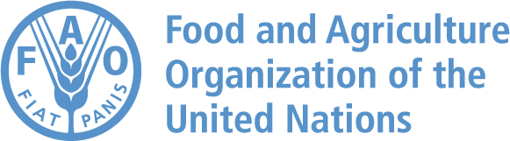

Enhancing Climate Resilient Agriculture in Southern Iraq

GCP /IRQ/073/CAN

Environmental and Social Management Plan (ESMP)

The designations employed and the presentation of material in this document do not imply the expression of any opinion whatsoever on the part of the Food and Agriculture Organization of the United Nations (FAO) concerning the legal or development status of any country, territory, city or area or of its authorities, or concerning the delimitation of its frontiers or boundaries.

This document is intended to be used solely for the purpose of FAO projects disclosure

October 2024

INTRODUCTION
The project ‘Enhancing Climate-Resilient Agriculture in Southern Iraq’, FAO project symbol GCP/IRQ/073/CAN, will be operational from 1 April 2023 until 31 March 2027 and is classified under FAO’s Environmental and Social Management Guidelines as moderate-risk. The purpose of this Environmental and Social Management Plan is to address any risks related to Output ‘1311 Solar systems installed on irrigation canals providing electricity to run surface water pumps of the Ministry of Water Resources in Najaf and Muthanna’ and support the procurement process for solar systems to be installed on irrigation canals and on farmers’ fields.
The overall project goal is to enhance the resilience of women and men in vulnerable agriculture households, in particular related to climate change risks, in the Southern Iraqi Governorates Babil, Missan, Muthanna, Najaf, Al Qadisiyah, Thi-Qar and Wasit.
Given the chronic and worsening water crisis in Iraq and that agriculture is consuming by far the most resources (approximately 91 percent in 2018) it is essential to carry out an integrated approach and planning to provide sufficient water to the whole population without discrimination of any kind, while at the same time guaranteeing adequate food production for commodities where Iraq has a competitive advantage and a sustainable environmental footprint. The project will address therefore the Water-Energy-Food Nexus and introduce different innovative approaches and technologies to promote among others Climate Smart Agriculture in the frame of Farmer Fields Schools, and Solar Energy as an instrument for enhancing agricultural value chain efficiency and rural electrification.
The project will address women’s strategic interests and practical needs. The active engagement of women farmers and the leadership of women as change agents for climate smart agriculture will help to enhance women’s adaptive capacity, reduce their work burden, strengthen their self-confidence, and increase their visibility and voice as key actors in the adoption of climate-smart agriculture. Recognizing that climate change affects men and women differently based on the gender differentiation of roles, asset ownership and decision-making, the project will use a gender lens across its interventions.
The initiative will highlight women’s key role in climate change adaptation by developing a cadre of village-based Climate Wise Women who will be able to support the adoption of climate smart agriculture through interactive dialogues and demonstrations at the village and homestead, thereby reaching out to women who are not able to avail formal training opportunities. These Climate Wise Women will also be able to carry the voices of rural women to policy makers and government functionaries through Governorate level forums organized for this purpose. In addition, the project will ensure the inclusion of women in Farmer Field Schools through mitigating the barriers that typically limit women’s participation. It will ensure the inclusion of women in non-traditional field and raise awareness on solar energy as an intervention for reducing women’s work burdens. The project will develop a gender-responsive rural solar electrification Road Map for the project areas¹. The project will be implemented in synergy with other FAO initiatives in the country and the region, in particular with the Green Climate Fund project proposal “Strengthening climate Resilience of Vulnerable Agriculture Livelihoods in Iraq (GCF SRV-ALI).
The complete list of outputs and activities of the project is reported in the table below.

¹ The output will focus on the rural project areas. However, in addition a GIS map will also be created analyzing the possibilities to upscale the solar system installation of output 1310 on water canals in other governorates.

Table 1. Complete list of outputs and activities of the project (this ESMP focuses only on Output 1311 and its activities)

 | Outputs and Activities Matrix
Intermediate  Outcome | 1100 - Enhanced application of climate smart agricultural production practices by smallholders in selected  commodities and target areas in Southern Iraq
Immediate  Outcome | 1110 - Enhanced knowledge and capacities of farmers, with special focus on women, to apply climate smart  agricultural production practices
Output | 1111 - Farmer field schools implemented to capacitate farmers in the application of CSA in Babil, Missan, Al  Qadisiyah, Thi-Qar and Wasit.
Activity | 1111.1 Design and implementation of the training curricula on climate-smart agriculture (topics: farm water saving irrigation methods / technologies; Resilient crop and soil agricultural management) using the FAO Farmer Field  Schools approach
Activity | 1111.2. Set-up and implement approx. 50 Farmer field schools for farmers interested in implementing Climate smart agriculture. Each group will consist of approx. 25 producers and will form an FFS based on common topics of  interest, territorial proximity and gender considerations.
Output | 1112 - Technical assistance provided to agricultural extension services to identify the best irrigation equipment  and management practices for climate smart agriculture
Activity | 1112.1 – Conduct assessment, analysis and stakeholder consultations and validations on the most suitable package of Climate Smart Irrigation Management equipment and techniques to be promoted in the selected governorates  and districts in the south of Iraq
Output | 1113 - Innovative agricultural equipment and inputs provided to farmers to improve CSA practices
Activity | 1113.1 Provide support to 300 smallholders with at least 30% women with inputs and/or innovative equipment for  Climate Smart Agriculture
Immediate  Outcome | 1120 – Enhanced knowledge and skills of farmers to utilize digital information tools for the adoption of informed  CSA practices
Output | 1121 - Knowledge management tools provided to farming households to disseminate CSA practices
Activity | 1121.1 Conduct a rapid assessment to prepare an action plan for ICT for Climate Change for farmers.
Activity | 1121.2 Disseminate the ICT products among farmers of each governorate and at the national level.
Activity | 1121.3 Conduct consultations to fine tune and update FAO knowledge management tools (RIMA, baseline/endline  assessments, El Rafidain apps, CSA+ methodology) and carry out field trials for validation.
Intermediate  Outcome | 1200 – Enhanced women's role as agents of change in the promotion of CSA through improved access to knowledge,  practices and technologies
Immediate  Outcome | 1210 - Increased women’s access to and participation in awareness raising awareness initiatives on CSA organized at  local level
Output | 1211 - A cadre of 50 Climate Wise Women (CWW) trained as change agents for CSA
Activity | 1211.1 Conduct training needs assessment and based on it training manuals will be designed for the Climate Wise  Women programme and tested through workshops
Activity | 1211.2 Select and train Master Trainers from a pool nominated by Directorate of Agriculture.
Activity | 1211.3 Train CWWs in accordance with specified criteria through a board comprising representatives from the Government Extension Departments, Master Trainers etc. Activity includes developing and implementing a training plan with details of selected training venues with dates and suitable timings, transportation arrangements for  master trainers and Climate Wise Women, daycare facilities, refreshments.
Activity | 1211.4 Develop and implement a social and behaviour change strategy for positioning, promoting and facilitating  the work of CWWs in the target area.
Output | 1212 – Climate Wise Women assisted in the organization of farm/homestead visits to demonstrate and train women  farmers on CSA in Thi-Qar, Missan, Babil, Wasit and Al Qadissiyah
Activity | 1212.1 Develop a field plan with Climate Wise Women for home visits to support climate resilient practices,  advocacy on climate resilient practices with communities and social media campaigns on climate change
Activity | 1212.2 Assist the CWW in the organization farm/ homestead visits to demonstrate and train women farmers in their  own villages
Intermediate  Outcome | 1300 - Increased application of solar energy by rural households in target areas to enhance sustainable surface  water supply and agricultural value chains
Immediate  Outcome | 1310 – Strengthened capacities of governmental and private stakeholders to operate and maintain solar energy  systems in support of irrigation systems, value chains and rural household security
Output | 1311 - Solar systems installed on irrigation canals providing electricity to run surface water pumps of the Ministry  of Water Resources in Najaf and Muthanna
Activity | 1311.1 Prepare engineering designs, bills of quantities, cost estimates and tender/procurement documents  (consulting services).
Activity | 1311.2 Provide services for control and supervision of construction works
Activity | 1311.3 Installation of solar systems on water canals including, testing, commissioning and start-up of the PV systems  in coordination with the Department of Water Resources (DoWR)
Activity | 1311.4 Operation and Maintenance training. The contractors will prepare the manual of operation and maintenance  of the implemented infrastructure, with detailed instructions about the steps to be carried out to guarantee a

smooth functioning of the installation. Furthermore the contractors will train the staff of the DoWR, given that the
agency will be responsible for the operation and maintenance of all investments after handing over.
Output | 1312 – Gender sensitive training activities conducted to increase technical capacity of men and women  stakeholders on solar energy installations
Activity | 1312.1 Organize training workshops for stakeholders on technical and economic advantages and feasibility of the Solar Powered Irrigation systems (SPIS). The trainings will address the topics planning, installation, supply, operation,  and maintenance and the financing of the systems.
Immediate  Outcome | 1320 – Enhanced capacity of governments and other related stakeholders to design and implement policies  related to solar rural electrification
Output | 1321 - Technical assistance to governmental agencies and the private sector for the elaboration of planning tools  for solar rural electrification
Activity | 1321.1. Elaboration of the of the Road map for rural solar electrification through the (i) Gender-aware review of the policy framework and strategies, needs, bottlenecks, and gaps (ii)Geospatial desktop analysis in combination with ground truthing carried out indicating the potential for off-grid, on-grid and decentralized solar energy project  development in support of rural electrification
Activity | 1321.2 Assessments of women-friendly and labour-saving solar energy applications identified and documented
Activity | 1321.3 Organize and facilitate multi-stakeholder consultation meetings and workshops for the validation and implementation of the Road map, together with awareness raising activities for the private sector on financing  possibilities.
Output | 1331 - Awareness raising activities implemented to increase knowledge of rural women and men on solar energy
Activity | 1331.1 To increase awareness of the general public rural women and men on solar energy, each year in a different municipality 1 public event demonstrating the functionality and advantages of solar energy in rural areas will be  organized
Activity | 1331.1 To increase awareness of the general public rural women and men on solar energy, each year in a different municipality 1 public event demonstrating the functionality and advantages of solar energy in rural areas will be  organized

This ESMP targets specifically the risks that could result from the installation of the solar photovoltaic system (Output 1311). The project foresees the installation of:
- Four solar photovoltaic (PV) systems, two in Najaf region and two in Muthana region, to power existing pumping stations to pump water from main canals to irrigation canals, totalling a capacity of 640 kWp (320 kWp of installed capacity per region), and
- 36 PV systems to be installed at farmers’ fields, with a capacity from 4 to 20 kWp, to pump water from irrigation canals to the fields in the same regions.
The PV systems is expected to significantly increase energy security and the large systems will be installed on 4 water canals in 2 regions, allowing saving of valuable agricultural land and reducing evaporation of water and algae growth. Stakeholders in the agricultural sector (e.g. farmers, Directorate of Water Resources of the Ministry of Water (DoWR) and Water User Association (WUA)) will dispose of a more efficient water conveyance due to a more reliable low emissions electricity supply. Furthermore, trainings for the design and operation of Solar Powered Irrigation systems and a gender-responsive Road Map analysing the opportunities to invest in solar energy for the benefit of rural electrification will be provided.
Moreover, the project will develop gender-sensitive media programs to be broadcasted in collaboration with Government, Universities and the media aiming to reach a wider audience of women and men farmers to raise awareness on climate smart approaches, including on the advantages of renewable energy.
In addition to the canals areas to be covered with solar panels, the project will construct an electrical room where all solar materials and final electrical connections to the existing pumps will be placed. Access to the new electrical room shall only be authorized for qualified people and restricted to any other personnel.
tremblm5
2024-05-30 11:55:18
--------------------------------------------
In addition to pictures, please provide a description of the sites that include natural and human features.
During the construction of this technical room, health and safety construction plan shall be taken into consideration; and the project might need for land excavation in some locations in order to prepare the concrete foundation at same level. Thus, the excavated materials shall be backfilled where needed, and the remaining materials shall be treated and sent to a specific land suitable for backfilling in coordination with the related authorities on site.
The following photos present the canals where the PV installations are foreseen; all water canals are flanked by roads on both sides, each with an approximate width of 10 meters, there are no residential areas nearby and minimal human activity along the length of the canal. The only infrastructure in close proximity to the water canal is the station, which houses the pumps, electrical rooms, and a guard room.
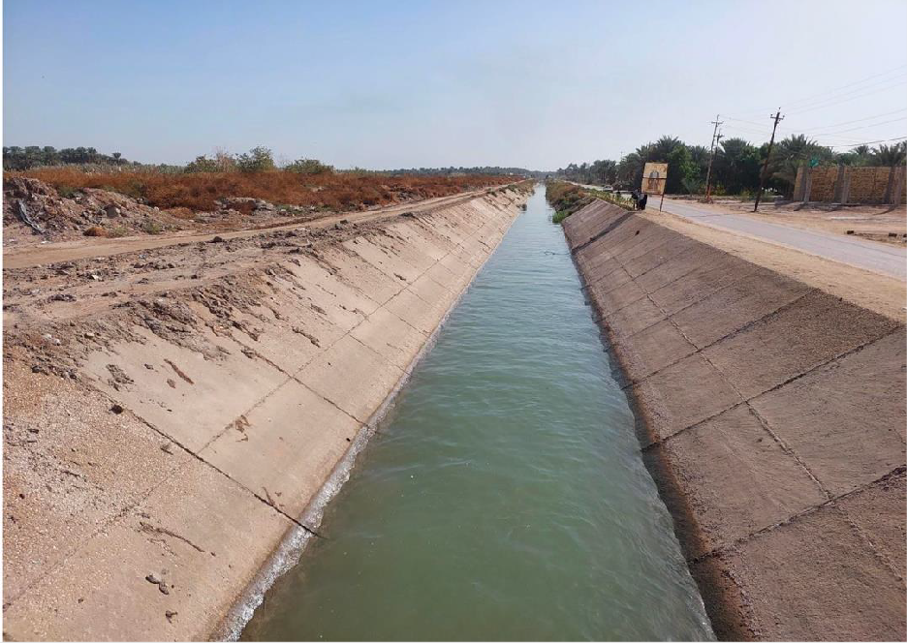
Photo by Rony Rihany

Figure 1. Najaf - Al Haydariya– Al Mounayther Canal.
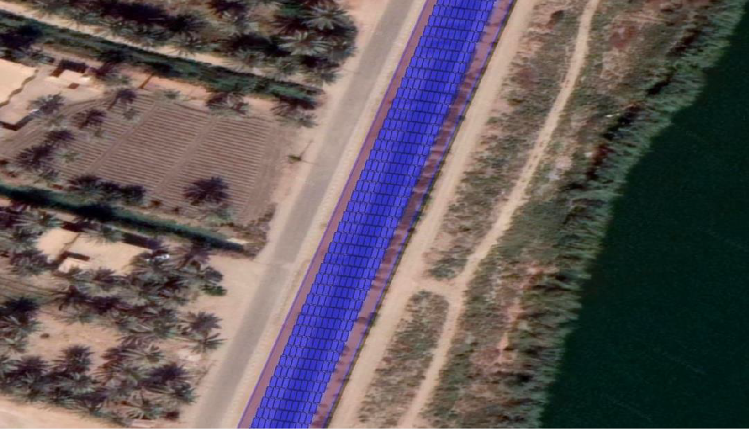
Photo by Rony Rihany/Helioscope software

Figure 2. Foreseen PV panel installation on Al Mounayther Canal.
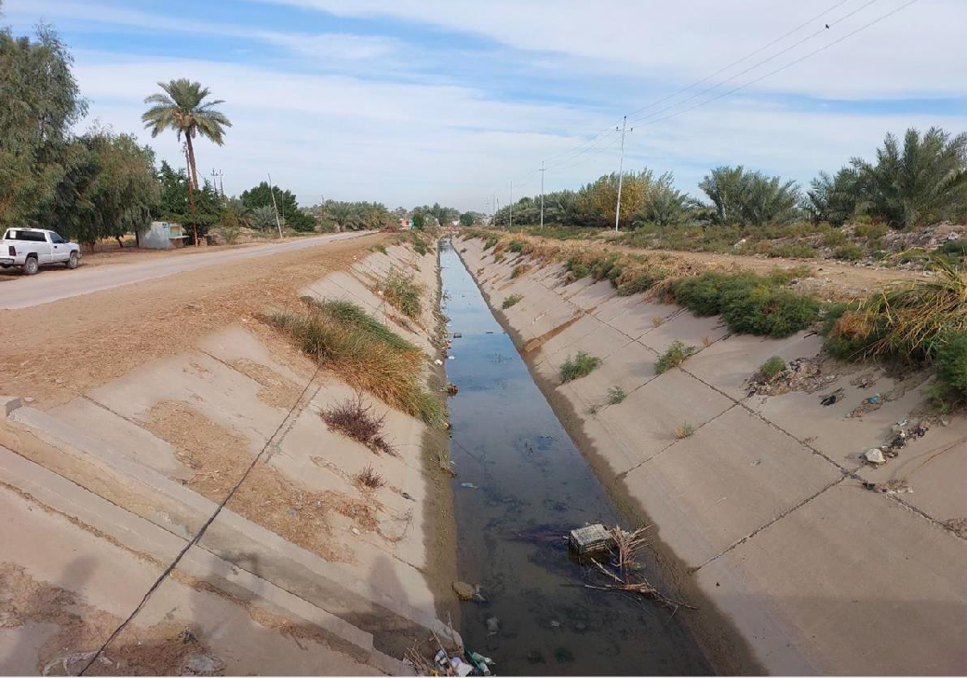
Photo by Rony Rihany

Figure 3. Najaf - Al Haydariya– Al Wasmiye Canal.
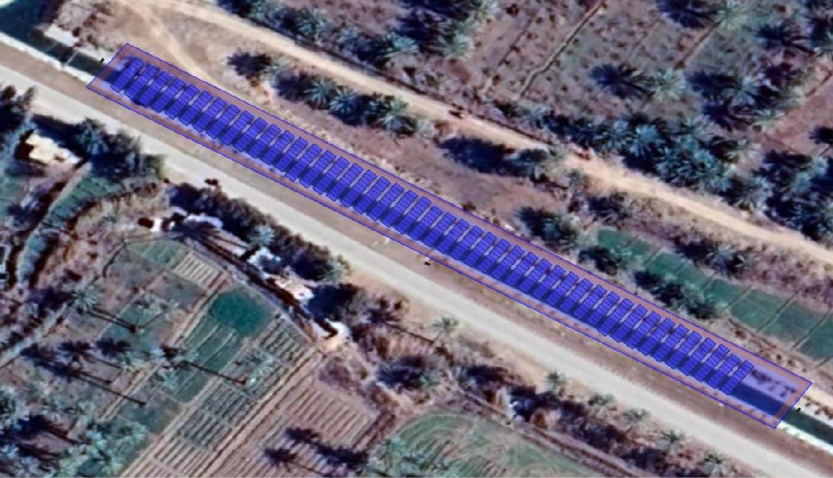
Photo by Rony Rihany / Helioscope software

Figure 4. Foreseen PV panel installation on Al Wasmiye Canal.
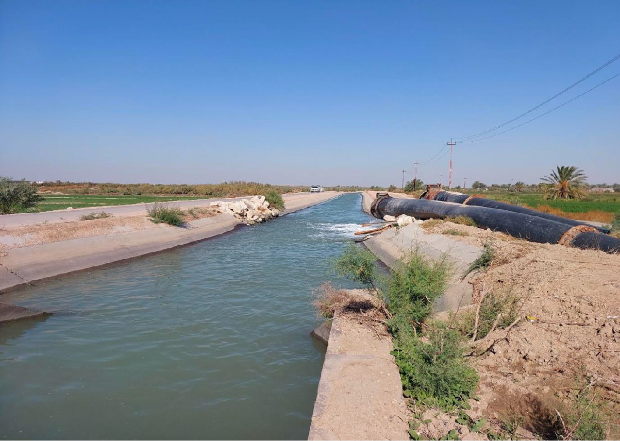
Photo by Rony Rihany

Figure 5. Al Mouthana - Al Safi Canal.
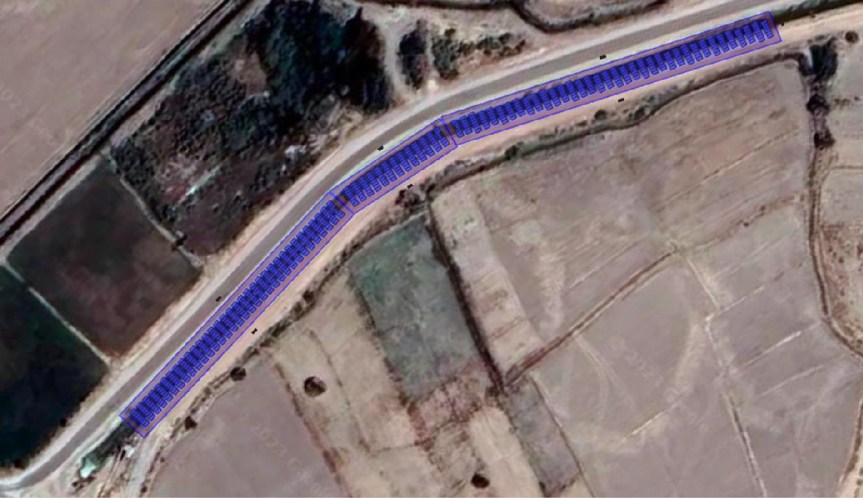
Photo by Rony Rihany / Helioscope software

Figure 6. Foreseen PV panel installation on Al Safi Canal.
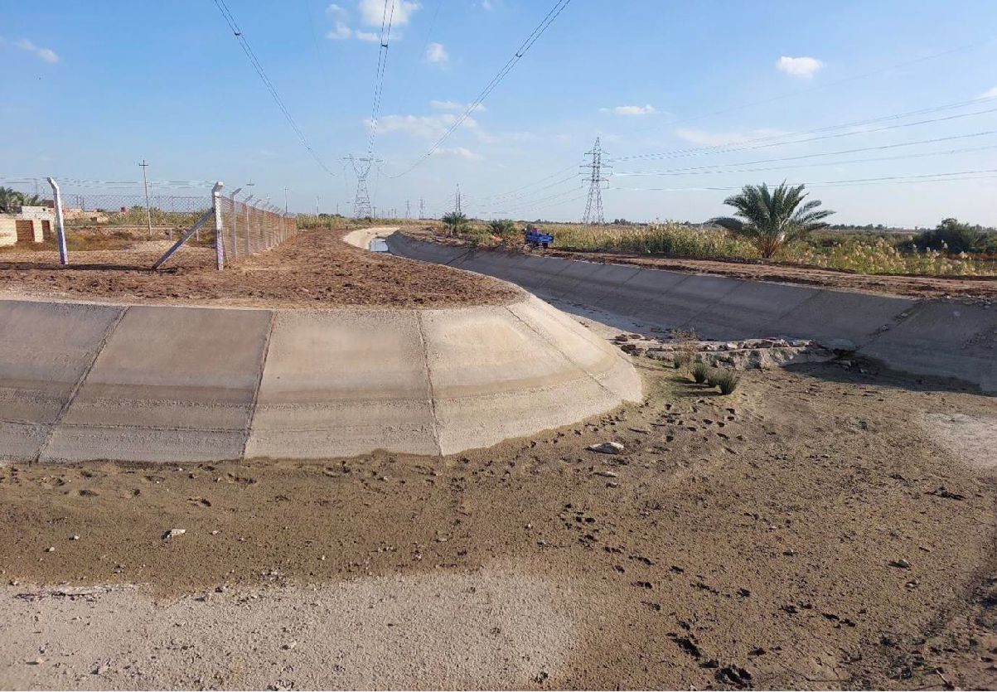
Photo by Rony Rihany

Figure 7. Al Mouthana - 2C Canal.
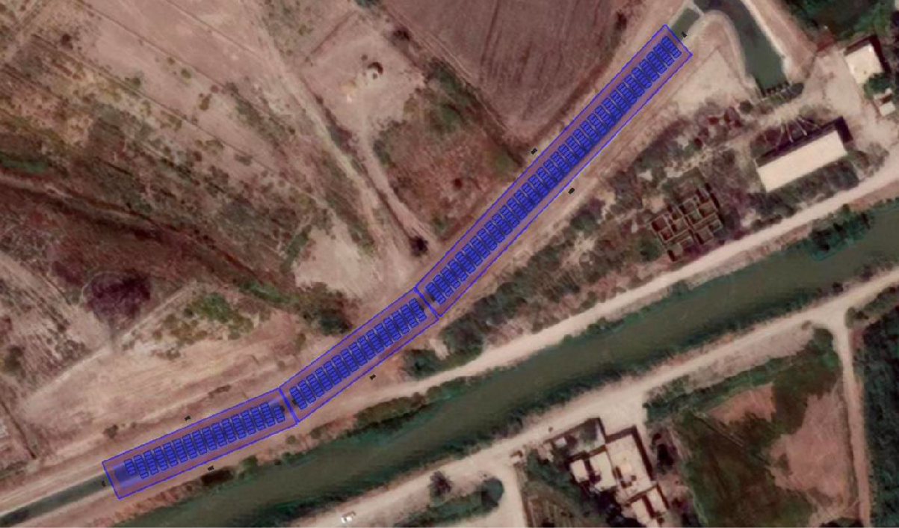
Photo by Rony Rihany / Helioscope software

Figure 8. Foreseen PV panel installation on 2C Canal.

All these installations (Figures 1-8) will be realized on the canals themselves, therefore there will be no or very minimal impact on land use change.

The panels would cover only a few hundred meters of canals, while the canals are several kilometres long. In reality, the PV panels will not cover completely the canals, but they will hang on the canals, by means of a metallic structure. This means that they will not close access to canals for small animals and insects.
Here are the technical characteristics of each PV system to be installed on irrigation canals:

Najaf - Al Haydariya– Al Mounayther Canal:
- Canal Width: 12.5 meters
- Required Width for solar: 16 meters
- Number of connected pumps: One pump 280 kW
- Required Solar system capacity: 320 kWp (equivalent to 552 panels)
- Maximum required canal length: 400 meters
- Annual solar energy production: 551,100 kWh

Najaf - Al Haydariya– Al Wasmiye Canal:
- Canal Width: 12.5 meters
- Required Width for solar: 16 meters
- Number of connected pumps: One pump 200 kW
- Required Solar system capacity: 250 kWp (equivalent to 432 panels)
- Maximum required canal length: 350 meters
- Annual solar energy production: 440,800 kWh

Al Mouthana - Al Safi Canal:
- Canal Width: 9 meters
- Required Width for solar: 12 meters
- Number of connected pumps: One pump 280 kW
- Required Solar system capacity: 320 kWp (equivalent to 552 panels)
- Maximum required canal length: 300 meters
- Annual solar energy production: 558,100 kWh

Al Mouthana - 2C Canal
- Canal Width: 10.5 meters
- Required Width for solar: 12 meters
- Number of connected pumps: One pump 160 kW
- Required Solar system capacity: 220 kWp (equivalent to 380 panels)
- Maximum required canal length: 250 meters
- Annual solar energy production: 373,000 kWh

The PV installations on irrigation canals will be used exclusively to power existing pumping stations. The pumping stations today use grid electricity, which is costly and unreliable. The stations will

continue to be connected to the national grid, and there is therefore no need to install batteries at the PV plants.
The amount of water that will be pumped after the PV installation is not going to change, since irrigation is regulated by the local authorities. Every pumping station and every farmer has an allocated amount of water for irrigation. Thus, there is no impact on the water resource.
Less electricity from the public grid will be used for irrigation thank to the PV systems, thus resulting in energy savings and related GHG emission avoidance.
The irrigation canals and the sites where the PV systems will be installed are close to community areas. In some instances, people are leaving just 50 m away from the solar plants.
The PV panels needed to power the pumping stations will have a negligible impact on land use change, since they will be installed on the irrigation canals by means of a metallic structure.
The project will install also 36 smaller PV systems to power existing irrigation pumps of smallholder farmers. These pumps bring water from the irrigation canals to the agricultural fields.
The PV panels needed to pump water from the canals to farmers’ fields will be ground mounted. The 36 systems will have different power capacity, therefore different land occupation. The land area needed varies between 22 m² and 100 m² per system.
Within the two governorates selected, the project has identified priority areas based on the targeted canals (primary and secondary), as well as to be-upgraded canals for solar system installation where, according to the referenced criteria, investments on canals, solar panels and adoption of climate resilient agricultural practices will have the higher potential impact. Additional criteria include: a) relevance of ecosystem services such as those provided by pastures and forests (i.e. protection, livelihood, water) benefitting communities; b) potential sustainable use of products and resources for local communities; c) availability of public land of at least 1,000 hectares; and d) agreement of communities for reducing pressure on identified areas.

Table 2. Climatic and socio-economic context
Governorate | Climate change  Historical trends (1980-2020)  Projected trends (2020-2060) under RCP 4.5 and 8.5 scenarios  all data per decade | Socio - economic context | Vulnerability of Agriculture
National | MEAN T °C:  Historical: +0.37°C  Projected: RCP4.5:+0.33°C; RCP8.5:+0.60°C  MIN T °C:  Historical: -0.38°C  Projected: RCP4.5:+0.23°C; RCP8.5:+0.32°C  MAX T °C:  Historical: +0.42°C  Projected: RCP4.5:+0.44°C; RCP8.5:+0.74°C  Annually accumulated precipitations :  Historical: +1.59 mm  Projected:RCP4.5:-4.39 mm;RCP8.5:-3.10 mm | 53% of HH are vulnerable to food insecurity  Proportion of people who are multidimensionally poor: 0.133  The Youth Development Index (YDI) on the national level: 0.641 | Agriculture is highly vulnerable, as a result of the increasing temperatures, changing precipitation patterns, and high evapotranspiration. These climatic changes will increase heat stress on crops, reduce soil moisture, and increase water consumption by crops.  Increasingly variable and unpredictable precipitation will increase crop failure risk and increase the dependence of crop production on irrigation water use.
Najaf | MEAN T °C:  Historical: +0.56°C  Projected: RCP4.5: +0.34°C; RCP8.5:+0.61°C  MIN T °C:  Historical: -0.41°C  Projected: RCP4.5: +0.22°C; RCP8.5:+0.30°C  MAX T °C:  Historical: -0.72°C  Projected: RCP4.5:+0.43°C; RCP8.5: +0.73°C  Annually accumulated precipitations : Historical: -1.03mm  Project.: RCP4.5:-1.86 mm; RCP8.5:-1.22mm  Potential Evapotranspiration (PET):  Project.:RCP4.5:+19.79 mm;RCP8.5:+35.02 mm | 87% of HH vulnerable to food insecurity  Proportion of people who are multidimensionally poor: 0.140  YDI: among the lowest of all Governorates 0.545 | The target areas have the smallest proportion of arable land, with the highest drought prone area and limited agriculture yields.  Flood irrigation is still prevalent leading to considerable inefficiencies in water use (only 30 to 35% irrigation efficiency) in the three governorates of Najaf, Karbala and Muthanna. The Euphrates River and its branches are the main source of water for irrigated agriculture.  Rice and corn farmers are forced to assess alternate options as the state has started to ban the production of rice and corn in years when there is drought or insufficient water in the irrigation system  Najaf represents the main area for rice cultivation in Iraq during the summer season. The summer season is the main agricultural season where rice constitutes more than 90 percent of cropped area. Given the importance of rice as a main food staple the climate resilience of the governorate is therefore of national interest  Agriculture is highly vulnerable, as a result of the increasing temperatures, changing precipitation patterns, and high evapotranspiration. These climatic changes will increase heat stress on crops, reduce soil moisture, and increase water consumption by crops.  Increasingly variable and unpredictable precipitation will increase crop failure risk and increase the dependence of crop production on irrigation water use.
Muthanna | MEAN T °C:  Historical: +0.32°C  Projected: RCP4.5:+0.36°C; RCP8.5:+0.60°C  MIN T °C:  Historical: +4.08°C  Projected: RCP4.5:+0.26°C; RCP8.5:+0.37°C  MAX T °C:  Historical: +1.37°C  Projected: RCP4.5:+0.45°C; RCP8.5: +0.73°C  Annually accumulated precipitations :  Historical: not enough data  Project.: RCP4.5:-1.64mm; RCP8.5:-0.78mm  PET:  Project.: RCP4.5:+20.85 mm; RCP8.5:+36.22mm | 67% of HH vulnerable to food insecurity  Proportion of people who are multidimensionally poor: 0.192  YDI: 0.554 (less than national average)

The economy in these selected areas is agriculture based and the economic development is hindered by poor infrastructure and lack of public and private investment. The selected governorates present some of the most destitute and neglected governorates in Iraq on various dimensions: vulnerability to climate change, socio-economic (poverty, food insecurity, unemployment…etc), and economic development. These dimensions are elaborated more in depth below. Also, these governorates receive limited attention from the major development partners in renewable energy, agriculture and climate change adaptation and mitigation.
The total population in the two governorates amounts to 2,342,135 inhabitants. Women constitute 49.4 percent of the total population in the country with target governorates recording slightly higher percentages than the national average (49.6 to 49.9 percent). Overall, the three governorates are among the least populated governorates in Iraq.
Table 3. Population of target governorates: Najaf, and Muthanna
 | Total Population | Share of Female (percent) | Avg. HH Size | Rural | HH | Female
Muthanna | 835,797 | 49.7 | 7.6 | 250,739 | 32,992 | 124,617
Najaf | 1,510,338 | 49.9 | 6.3 | 453,101 | 71,921 | 226,097
National | 39,127,889 | 49.5 | 6 | 11,738,367 | 1,956,395 | 5,810,492
Total 2 Governorates | 2,342,135 | 49.7333 |  | 703,840 | 104,913 | 350,714

Source: Central Statistical Organization (CSO), Ministry of Planning, Government of Iraq, 2019 / Data on Average HH Size is taken from Comprehensive Food Security and Vulnerability Analysis (CFSVA) 2016, World Food Programme and CSO, Government of Iraq / Data on number of villages taken from Governorate Rural Development Surveys (2017)
Based on a poverty mapping study [WB, 2015], the national poverty rate in Iraq was 18.9 percent in 2012. Muthanna is the poorest governorate in Iraq, and the proportion of poor Iraqis households in Muthanna is nearly triple that of Iraq’s national average.² Poverty in Muthanna stands at 52.5 percent, while in Najaf is 10.8 percent. Najaf witnessed a drastic reduction in poverty rates from 2007 to 2012, where it was 36.9 and 24.4 percent, respectively, while in Muthanna poverty increased from 48.8 to 52.5 over the same period.
The share of households vulnerable to food insecurity is alarmingly high in all two governorates—67 percent in Muthanna, and 87 percent in Najaf (Table 4)³, all of which are above the national share of 53.2 percent.
Table 4. State of Food Security in project areas
 | Food Security Zone | Food Secure HHs (percent) | Marginally Food Secure HHs / Vulnerable to Food Insecurity (percent) | Food Insecure HHs (percent)
Muthanna | Drought Prone Desert Area | 22 | 66.7 | 11.3
Najaf | Drought Prone Desert Area | 10.3 | 87.3 | 2.5
National | -- | 44.3 | 53.2 | 2.5
Source: CFSVA 2016, WFP, FAO and Government of Iraq / Data on Food Security Zones taken from Iraq Socio-Economic Atlas, WFP (2019)

Women’s labour force participation is markedly low in the target governorates and women’s unemployment is a significant national issue. In comparison to 81 percent at the national level, nearly 90 percent of women, excluding internally displaced persons (IDPs), are out of the labour force in Muthanna, 79 percent in Najaf. Within the three governorates, women’s unemployment is highest in Najaf, 31.4 percent, which is significantly greater than the national average of 22 percent. The unemployment rate for young women is twice the rate for men. In 2017, about 56 percent of young women were unemployed compared to 29 percent for young men⁴. Overall, the national unemployment rate is high at 10.8 percent.⁵ Muthanna has one of the highest unemployment rates, 14.5 percent, among the three governorates. The unemployment rate is roughly 9.5 percent in Najaf.
Illiteracy is widespread in the target governorates, especially among women, and the prevalence rate is highest in Muthanna (30 percent).⁶ Although the completion rates vary in the targeted governorates, the trend of decreasing completion rates as the level of education increases is common to all, i.e., primary level completion rates are nearly twice that of upper secondary level. The education completion rates are even lower in the other two governorates, where merely 24 percent completed upper secondary in Muthanna and 37.5 percent completed it in Najaf (Table 5).⁷
As for gender disparities, percentage of total completion rates of primary and upper secondary education is higher for boys than for girls, whereas, it is slightly higher for girls at the lower secondary level than boys are. Moreover, completion rate for all three levels of education is higher in urban areas and households in high wealth quintiles. Agriculture is still the only livelihood for the poor and food insecure of the country.

Table 5. Illiteracy and completion rates (primary to upper secondary)
 | Illiterate ( percent) (>= 6 years of age) | Illiterate – male ( percent) | Illiterate – female ( percent) | Completion Rates – Primary | Completion Rates – Lower Secondary | Completion Rates – Upper Secondary
Muthanna | 30.3 | 22.7 | 37.8 | 68.7 | 29.9 | 23.9
Najaf | 20.5 | 15.4 | 25.8 | 64.7 | 39.9 | 37.5
National | 17.8 | 12.9 | 22.8 | 75.7 | 46.4 | 44.3
Source: Data on illiteracy taken from CFSVA 2016, WFP, FAO, CSO Government of Iraq / Data on completion rates taken from Iraq Multiple Indicator Cluster Survey (MICS) 2018, CSO, Government of Iraq and UNICEF

The two governorates have the smallest proportion of arable land [WFP, 2019], with the highest drought prone area, the highest percent of food insecure males (up to 11 percent) and females (up to 15 percent) and the highest percent of female-headed households (up to 14 percent). A quarter of the population lives below the national poverty line (24 percent), with Muthanna considered as the poorest governorate. The average unemployment in the governorates is around 14 percent, and almost half (45 percent) of jobs are unwaged, mostly in the agriculture and trade. According to the 2018 data, only 18.1 percent of women over 15 years are economically active compared to 74.1 percent of men.⁸ Moreover, women are excluded from the industry sector represented only by 3.9 percent (mostly related to the oil sector) compared to men (23.4 percent), whereas they are fairly more active in the agriculture sector (mostly informally and with poor social protection), accounting 43.9 percent of labour compared to 12.3 percent men.⁹ In 2011, the percentage of women in agricultural employment was 49 percent, while men represented 17.1 percent. In 2017, 43.7 percent of women and 16.1 percent of men were working in the agricultural sector.
In Muthanna, 44.5 percent agricultural households contract farmland, while 39.7 percent own it, the highest proportion of households who own land among the three governorates. Similar to Karbala, nearly half of the agricultural households in Najaf do not own the land but control it (48.6 percent), while a significant proportion, 10.9 percent, rents it without a contract, see Table 6.

Table 6: Agricultural households’ access to land
 | Agricultural households ( percent) –  Own land | Agricultural households ( percent) –  Not owned but has control | Agricultural households ( percent) –  Contracted | Agricultural households ( percent) –  Government land | Agricultural households ( percent) –  Rented without contract
Muthanna | 39.7 | 4.4 | 44.5 | 4.7 | 6.7
Najaf | 28.6 | 48.6 | 10.3 | 1.6 | 10.9
National | 46.6 | 20.7 | 25.1 | 3.4 | 3.8
Source: Comprehensive Food Security and Vulnerability Analysis (CFSVA) 2016, WFP and Government of Iraq

Discussions with local non-governmental organizations (NGOs) working in target governorates reveal that women are involved in the complete farming life cycle, from cultivation to selling produce, i.e., there are few stages or activities exclusive to men now. In Najaf, women play a lead role in the agriculture sector, sharing the responsibility of land preparation, planting/sowing, irrigation, applying fertilizer, weeding, harvesting, and even marketing. While women do not participate in land preparation and marketing produce in Muthanna, it is generally the women’s responsibility to manage family’s livestock and poultry in the governorate.
Women in rural areas spend long hours every day in crop and livestock production. In crop production, they are involved in almost all aspects, with the exception of land preparation and other mechanized and capital-intensive activities. The tasks women perform are often non-mechanized and labour-intensive: they broadcast seeds and fertilizers by hand, hand weed and harvest, pick fruits and vegetables and carry produce. Women also spend many hours in post-harvest activities such as threshing, cleaning, sorting and grading while men are performing most of the mechanized activities, land preparation, irrigation, and marketing of the products. Women in these areas are facing greater food insecurity as well as more barriers to land tenure, education, formal employment and access to finance, which hinders their progress out of poverty and limits their adaptation to climate change.
About 11 percent of HHs in Muthanna are women-headed, and 11 percent in Najaf. Moreover, women-headed households that own or have control over of farmland is comparatively higher in Muthanna and Najaf (5 to 8 percent) than Karbala (1 to 4 percent). Similarly, a significantly greater percentage of women-headed households’ own livestock in Muthanna (5 to 10 percent) than Karbala and Najaf (0.1 to 5 percent), see Table 7.¹⁰

Table 7. Female-headed households’ ownership of farmland and livestock in targeted governorates
 | Female-headed households ( percent) | Female headed households that owned or had control of farmland ( percent) | Female-headed households that owned livestock ( percent)
Muthanna | 11.5 | 5 - 8 | 5.1 - 10
Najaf | 10.6 | 5 - 8 | 0.1 - 5
Source: Comprehensive Food Security and Vulnerability Analysis (CFSVA) 2016, WFP, FAO, CSO Government of Iraq

The prevalence of youth illiteracy and unemployment is highest in Muthanna than Najaf. While the overall youth literacy rate in Najaf is between 75 to 85 percent, it is less than 75 percent in Muthanna. Likewise, the literacy for young women is less than 65 percent in Muthanna, nearly 10 percent less than that of the other Najaf (75.1 to 80 percent).¹¹
The youth unemployment rate in Muthanna hovers in the range of 21 to 25 percent, whereas, the rate is somewhere between 11 to 15 percent in Najaf. Still, Young men’s unemployment rate is considerably higher in Muthanna, 16 to 20 percent.
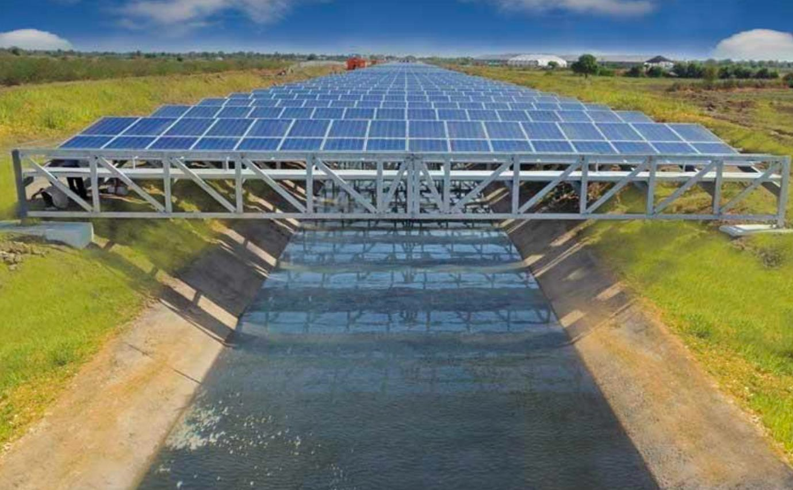
Photo source via https://www.paktribune.com/article-details/canal-solar-power

Figure 9. Example of PV installation of an irrigation canal.

POLICY, LEGAL AND INSTITUTIONAL FRAMEWORK
Iraq’s National Climate Change Mitigation and Adaptation Priorities
The Iraqi government considers adaptation (thus irrigation) and climate mitigation to be priorities for the country, particularly in addressing the impacts of climate change on poor and vulnerable communities. In 2021, Iraq renewed its commitment to combating climate change with the first Nationally Determined Contributions (NDC) document to the Paris Agreement and including commitments on reducing greenhouse gas emissions. The NDC document includes the concept of green economy, focusing on renewable energies and clean mechanisms, and trying not to exceed the rate of global temperature 1.5 °C above the mean of the global temperature before the industrial revolution. Related to Water, the NDC aims at raising the efficiency of irrigation water utilization through the application of enhanced practices and updated and modern technology in order to adapt to the sharp decrease in water resources. Related to agriculture the priorities are (i) Reducing and rehabilitating soil degradation and improving land management practices; (ii) modernizing, improving and developing agricultural practices and developing livestock in order to achieve the principles of adaptation to face climate changes; and (iii) the establishment of greenhouses and plastic farms and laboratories for tissue reproduction of varieties resistant to climate changes). Iraq NDC will attract new investment opportunities and provide more engagement for the private sector in the climate change field.
Government of Iraq’s Strategy for the Reduction of Poverty in Iraq (2018-2022)
The Strategy for the Reduction of Poverty in Iraq (PRS) adopts the 2030 Sustainable Development Goals as a general framework. Within that, the PRS has a goal of reducing poverty by at least 25 percent by 2022. The Strategy formulates a plan to contribute to improving standards of living, protection against risks and hazards and economic empowerment to turn the poor into productive individuals who are economically and socially integrated, rather than being dependent on their communities or the charity of others. In this context, the Strategy adopts six outcomes that represent the key dimensions of poverty, including “sustainable income for the poor from work”. This includes supporting factors for increasing productivity of agricultural work be made available to the poor through the provision and maintenance of infrastructure supportive to production and marketing, setting programmes to train farmers on modern agriculture and irrigation techniques and reviewing the package of agricultural legislation and policies in favour of poor farmers.
Government of Iraq Strategic Plans
The objectives of the Strategy Plan for the Ministry of Agriculture (2015-2025) are to: (i) increase plant production (in particular wheat, barley, vegetables, potatoes and dates); (ii) increase livestock production (in particular sheep, goats, cattle and buffaloes, as well as poultry and fish); (iii) increase public and private investment in the agriculture sector; (iv) improve agricultural services (in particular, legislation, research, extension, finance, insurance, human development/training, management, machinery, marketing, plant protection and animal health); and (v) support achievement of the national Sustainable Development Goals.
The key common priorities across the Strategy for Water and Land Resources in Iraq (2014) and National Strategy and Plan of Action for Protecting the Environment in Iraq (2012) relate to the need for improved and integrated ecosystem management and restoration. Iraq, being an arid and semi- arid country with a decreasing supply of irrigation water (from rivers originating in neighboring countries and non-renewable groundwater resources), is facing significant challenges because of its deteriorating natural resource base, climate change threats and ongoing recovery from three wars over the past three decades.
Iraq Vision 2030, “The Future We Want” (2019)
The Iraqi vision 2030 is a road map and an action plan, which all ministries and local governments should adhere to ensure the vision realization. The Iraq Vision involves five sections which express Iraq’s national goals (man building, good governance, a diversified economy, safe society, and sustainable environment) and meet the UN sustainable development pillars: people, prosperity, planet earth, peace, and partnerships.
Alignment of the project is identified in particular with the priority area “Sustainable Environment” and its goals: (5-1): Reduce environment pollution and greenhouse emissions; (5-2): Efficient use of water resources; (5-3): Environmental conservation; (5-4): Develop the consumption and production patterns to achieve environmental sustainability.
National Development Plan (NDP) (2018-2022)
The NDP lays out the goals for the water sector, including on agriculture and irrigation, and the means to achieve them. The NDP identifies among others the following priorities related to the project:
- Increasing the agricultural sector share in GDP
- Achieving sustainable food security
- Securing the annual demand for water for sustainable uses in the (agricultural, industrial, municipal) fields and achieving water balance (by reducing the annual demand for water 500 million m3)
- Working on providing sustainable water resources
- Protecting the environment from contamination and handling environmental problems resulting from oil and gas activity of existing facilities and reducingCO2 emissions.
- Empowering women in terms of health, economics, science and security and increasing their participation in the private sector.
The United Nations Sustainable Development Cooperation Framework (UNSDCF)
The UNSDCF for the period 2020 – 2024 in Iraq is a critical programming instrument for the UN System to ensure a harmonized and collective response to national humanitarian and development challenges, as well as to support the national strategic plans related to the achievement of the Sustainable Development Goals/Agenda 2030. There are five priority areas identified and the project has strong synergies with area 4 ”Promoting Natural Resource and Disaster Risk Management, and Climate Change Resilience” and its outcome 4.1: “4.1: Strengthened and resourced policies and frameworks are implemented for using and managing natural resources (including trans-boundary issues), developing renewable resources, and increasing resilience to climate change, environmental stress and natural hazards, and man-made and natural disasters”.
Policies on Gender Equality and Women’s rights
Iraq ratified the Convention on the Elimination of All Forms of Discrimination against Women (CEDAW) in 1986 but has yet to ratify the Optional Protocol on violence against women. There are some government policies and strategies aimed at promoting and protecting women’s employment and economic empowerment such as the National Action Plan for the Implementation of United Nations Security Council Resolution (UNSCR) 1325 (NAP 1325), the 2014-2018 National Strategy for the Advancement of the Status of Iraqi Women, and the Iraq Labour Law of 2015. These laws provide paid maternity leave, prohibit discrimination against women during recruitment and in the workplace, and increase female participation in the public sphere. The National Strategy on Violence against Women and Girls 2018-2030, provides an overall framework on which policy and decision makers will draw to take concrete actions aimed at preventing violence against women and girls and protecting survivors of violence. There are no specific policies on the empowerment of rural women, and neither is there a gender strategy in place for the agricultural sector. However, findings from the present assessment indicate that the implementation and enforcement of these policies is inconsistent, particularly in the private sector.
Canada’s Impact Assessment Act
Canada’s Impact Assessment Act (IAA), which came into force in 2019, mandates that environmental, health, social, and economic impacts of projects be carefully assessed before proceeding. The Act focuses on sustainable development by ensuring that decisions on major projects consider environmental protection, as well as the needs of future generations. The IAA incorporates public consultation, indigenous engagement, and scientific evidence in its assessments. Environmental considerations under the IAA include potential harm to air, water, soil, and biodiversity, along with the cumulative impacts of a project on ecosystems. Proponents of projects are required to demonstrate how they will mitigate negative environmental effects while promoting sustainable practices.
One of the critical aspects of the IAA is its emphasis on climate change considerations. Projects must assess their greenhouse gas emissions and explore ways to minimize their carbon footprint. Additionally, the IAA ensures that projects are evaluated for their potential to affect vulnerable species and their habitats. For example, projects located near protected areas or regions with significant biodiversity are subject to more stringent assessments.

ENVIRONMENTAL AND SOCIAL BASELINE
The photovoltaic installations are foreseen in the rural regions of Najaf and Muthanna, next to village settlements. There are two regions situated in southern Iraq, which are rich in both environmental diversity and cultural heritage. As the proposed site for a photovoltaic system installation for irrigation canals, understanding the intricate interplay between the physical, biological, socio-economic, and cultural aspects of these regions is paramount. This analysis delves into the environmental and social context of Najaf (Al Haydariya) and Muthanna, focusing on the immediate implications of the proposed project.
tremblm5
2024-05-30 12:07:14
--------------------------------------------
What is the relationship betwee the project and the biodiversity context?
Physical Environment
The topography of Najaf (Al Haydariya) and Muthanna is characterized by predominantly flat terrain interspersed with occasional low-lying hills. This geographical feature plays a pivotal role in shaping the region's agricultural landscape and infrastructure development. The flat terrain facilitates agricultural activities, making these regions agriculturally significant within Iraq. However, it also presents challenges in terms of water management and drainage.
The climate in Najaf and Muthanna is classified as desert, characterized by scorching summers and relatively mild winters. This arid climate poses significant challenges to agricultural productivity, as water scarcity becomes a pressing issue during the long, hot summers. The irregular and scarce rainfall exacerbates these challenges, necessitating efficient water management strategies for sustainable agricultural practices.
The soil composition in Najaf and Muthanna varies from sandy to clayey soils, with implications for agricultural suitability and productivity. While sandy soils are conducive to water drainage, they often lack essential nutrients, requiring soil enrichment strategies. On the other hand, clayey soils retain moisture but may be prone to waterlogging, necessitating careful irrigation management to prevent waterlogging-related soil degradation. It is important to note that the project, through the adoption of the conservation agriculture principles (minimum tillage, soil cover, crop rotation), organic fertilization, and the selection of appropriate crop varieties, will strongly contribute to enhancing the water retention capacity of the soils, reducing irrigation water requirement, and optimizing water productivity.
Infrastructure development in Najaf and Muthanna remains a pressing need, particularly in rural areas. The existing infrastructure, including transportation networks and access to basic services, is inadequate to meet the growing needs of the population. Improving infrastructure, especially in terms of water supply and distribution, is crucial for supporting agricultural activities and enhancing the overall socio-economic development of the regions.
Biodiversity context
Najaf and Muthanna are characterized by a combination of desert ecosystems, river-fed wetlands, and agricultural landscapes. The biodiversity in these governorates is shaped by the presence of the Euphrates River, which supports a range of wetland and marsh ecosystems. In Najaf, the Najaf Sea and the nearby desert provide habitats for migratory birds, small mammals, reptiles, and unique plant species. Muthanna, largely desert, also relies on the limited water resources from the Euphrates for its biodiversity, supporting species adapted to arid conditions.
However, biodiversity in these areas faces severe pressures due to factors like water scarcity, increasing salinity in agricultural lands, desertification, and habitat loss. Overgrazing and unsustainable agricultural practices have further stressed the fragile ecosystems. Muthanna, one of Iraq's poorest regions, has seen growing agricultural activity near water sources, placing additional pressure on both land and water resources.
Efforts to enhance biodiversity in Najaf and Muthanna must address these challenges. In this context, the installation of solar panels over water canals could play a crucial role in preserving biodiversity. Solar panel structures reduce water evaporation by shading canals, maintaining water levels that support local plant and animal life. Additionally, reducing evaporation helps sustain agriculture without increasing water extraction, indirectly supporting the surrounding ecosystems. The absence of nearby housing or human activity along the canals also means that such interventions would have minimal disruption to local wildlife, making it a viable solution for promoting sustainable environmental practices while preserving biodiversity in the region.
Biological Environment
The target regions are home to a diverse range of flora and fauna adapted to desert conditions. Despite the harsh climate, numerous plant and animal species thrive in these regions, contributing to their ecological richness. However, habitat degradation due to human activities poses a significant threat to biodiversity conservation in Najaf and Muthanna.
Several endangered animal species can be found in Iraq's Najaf and Muthanna governorates, including the Persian leopard, striped hyena, and Euphrates soft-shell turtle. These species face threats from habitat degradation due to human activities. Climate change and desertification, exacerbated by human activities and infrastructures, are causing further habitat loss.Endangered species are of particular concern in Najaf and Muthanna, as habitat loss and fragmentation continue to threaten their survival. Efforts to conserve and protect endangered species are essential for maintaining the ecological balance of the regions. Sensitive sites, such as wetlands and riparian areas, serve as critical habitats for wildlife and play a crucial role in maintaining ecosystem stability. Preserving these sensitive sites is imperative for safeguarding biodiversity and ecological integrity in Najaf and Muthanna.
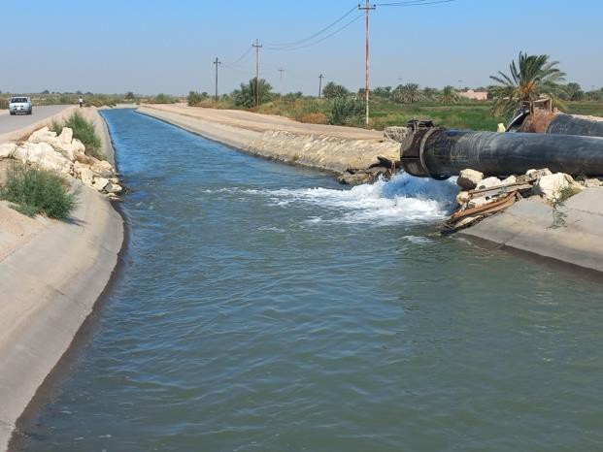  Figures 10-11: Photos by Rony Rihany | 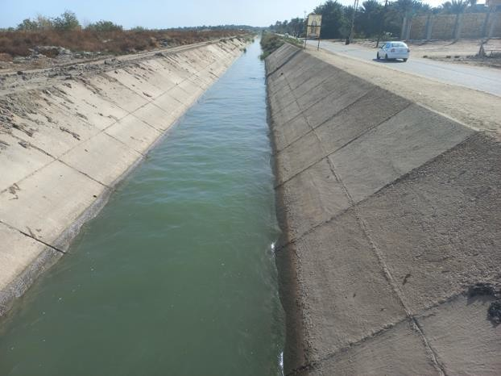

Figures 10-11. Targeted canals (Al Safi Canal - Muthanna).
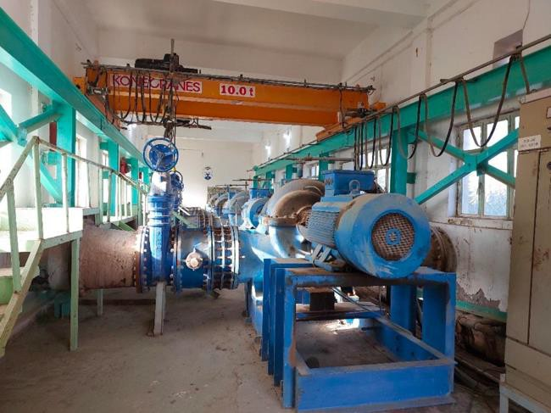  Figure 12-13: Photos by Rony Rihany | 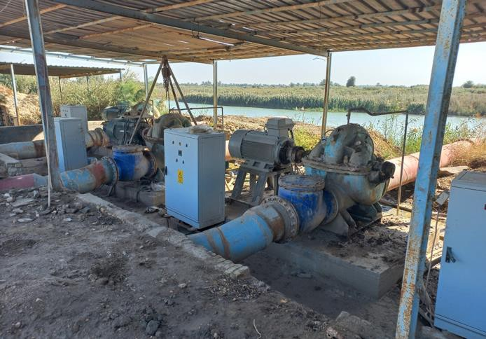

Figures 12-13. Existing pumping stations.
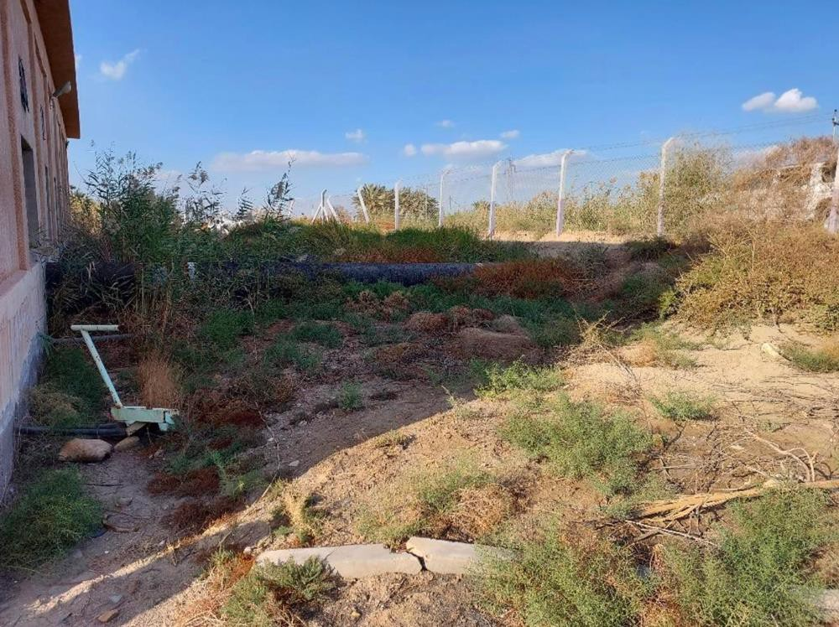
Photo by Rony Rihany

Figure 14. Example of location where to construct the new technical room for the solar PV system.
Socio-economic and Cultural Environment
The socio-economic landscape of Najaf and Muthanna is shaped by factors such as population dynamics, land use patterns, poverty trends, and cultural heritage. The predominantly rural population relies heavily on agriculture as the primary source of livelihood, highlighting the importance of sustainable agricultural practices for food security and economic stability.
Population growth in Najaf and Muthanna poses challenges in terms of land use and resource management. The pressure on land and natural resources intensifies as the population grows, leading to increased competition for scarce resources. Addressing the underlying causes of poverty, such as limited access to education and healthcare, is essential for promoting inclusive and sustainable development in Najaf and Muthanna.
Community structures and capacities play a crucial role in governance and decision-making processes in Najaf and Muthanna. Strong social ties and community-based organizations contribute to the resilience of local communities, enabling them to cope with environmental and socio- economic challenges. However, disparities in access to basic services and employment opportunities persist, exacerbating social inequalities and hindering equitable development.
Cultural heritage is a significant aspect of life in Najaf and Muthanna, with historical sites and monuments of religious significance dotting the landscape. Preserving cultural heritage not only fosters a sense of identity and belonging but also enhances the region's tourism potential. However, rapid urbanization and infrastructure development threaten the integrity of cultural heritage sites, underscoring the need for sustainable development practices that balance economic growth with cultural preservation.
Najaf and Muthanna in Iraq represent a complex interplay of environmental, social, and cultural factors that shape the livelihoods and well-being of local communities. The proposed photovoltaic system installations for irrigation canals and households hold the potential to contribute to reduce the pressure on the energy system which is unreliable, while ensuring irrigation services. The irrigation (irrigation time and water distribution) is anyway regulated by the local authority, in order to avoid overexploitation and to ensure fair use of this limited resource. However, it is essential to carefully consider the environmental and social implications of the project to ensure its long-term sustainability and benefits for the local communities.
The stakeholder engagement exercise held during July 2024 as part of the Stakeholder Engagement Plan (SEP) included Focus Group Discussions (FGD) with women and men farmers, Extension Officers, Women’s Empowerment Directorate representatives, in Najaf and Muthana in communities that will benefit from the solar panel installations, as well as national level NGO’s working with women, children, the environment and conservation, and there is widespread support and demand for the interventions. The majority of stakeholders said that it would help them and their communities a great deal to have the access to renewable, clean and reliable energy supply given that right now the energy is not reliable. Several NGO stakeholders emphasized how important it would be for these communities to have the access to clean and renewable energy and that it could even improve children’s nutrition, and praised similar interventions in the past by FAO that they have seen. No one expressed an objection nor that the installations would be unattractive aesthetically for their communities, in fact on the contrary all responses were that they would give a modern touch or to enhance the visual of the community. However, a number of actors expressed the need for fencing off the facilities to prevent theft or children or animals to get hurt, and to put plants, flowers and greenery by the solar panels in order to improve the look. Also, a number of farmers expressed some concern that the land taken up by the installations could instead be used for agriculture, therefore raising some concern of economic displacement which should be monitored, although it may or may not occur.

RISK CLASSIFICATION AND MANAGEMENT
The project overall is categorized as moderate-risk under FAO’s Environmental and Social Management Guidelines. The screening checklist as completed during formulation is annexed to this ESMP.

DESCRIBE THE POTENTIAL ENVIRONMENTAL AND SOCIAL RISKS AND IMPACTS
The activities covered by this ESMP trigger the following FAO safeguards standards:
  - ESS1: Natural Resources Management
  - ESS7: Decent Work (for the construction phase)

Implementing PV modules on irrigation canals in Najaf and Muthanna, and the installation of PV system to power irrigation at smallholders’ fields, entails (some) potential risks and benefits for the local communities and the environment. This analysis aims to identify and examine the possible adverse impacts and risks associated with the project's activities, while also exploring avenues for enhancing its positive outcomes. It delves into each phase of the project's lifecycle, considers cumulative impacts, and addresses cross-cutting issues to offer a thorough understanding of its implications.

Potential Risks and Adverse Impacts
During the construction and operation phases, several risks may emerge from the large PV installations:
- Excavation and construction activities could temporarily disrupt the land, adversely impacting nearby agricultural activities. These activities may also lead to soil erosion, causing relatively limited sedimentation in nearby water bodies and slightly compromising water quality only during the construction phase. Furthermore, construction-related noise and dust pollution pose health risks to local communities. However, these impacts are very limited for this type of installation on a metal frame.
- Accidents or injuries may happen during excavation and construction activities if all safety measures are not in place and workers are not provided with personal protective equipment (PPE).
- Insufficient maintenance may lead to operational inefficiencies, reducing the project's effectiveness and lifespan.
- The visual impact of PV modules on the landscape may disrupt the aesthetic value of the surroundings. However, no stakeholders interviewed as part of stakeholder engagement exercise in July 2024 expressed concern about this, in fact most expressed on the contrary that it would add aesthetic attractiveness to their communities. Several did suggest planting flowers and greenery by the installations to enhance the beauty.
- In the decommissioning phase, inadequate waste management during the disposal of decommissioned PV modules could lead to environmental pollution. Land rehabilitation after decommissioning is crucial to prevent land degradation. Legacy pollution from decommissioned PV modules may persist in the environment, posing long-term risks to ecosystems.
- Water management through PV installations (complemented by the unreliable national electricity grid) could enhance water security, but mismanagement could exacerbate water scarcity issues. Ensuring social equity of the water resource use requires active participation and consultation with all stakeholders, particularly marginalized groups. This is anyway already practiced locally. Local authorities carefully manage irrigation water, which is a scarce resource in the regions, however, the stakeholder engagement exercise held in July 2024 showed that the vast majority of stakeholders participating feel that the water is not managed properly, and that politically powerful and wealthier landowners closer to water sources can take more than their fair share of water. Stakeholders requested overwhelmingly for there to be a mechanism set up by FAO to ensure fair distribution of water.
- Regarding marginalized groups, multiple focus groups were held with small, low-income farmers in the communities receiving solar panel installations, including separately for women farmers. Therefore, women and low-income actors are well represented. Also, national level NGO's including those working with people with disabilities in Iraq, the elderly, children, and women, were consulted and asked their opinion about the solar panel installations. No stakeholders expressed opposition, and most expressed enthusiastic support, including for the aesthetics of the installations, that it would add an attractive touch, but more importantly to give energy security to communities that currently experience outages frequently and depend on unreliable energy sources. One NGO felt that the solar panels would improve children's nutrition in those communities. There were some concerns by a few stakeholders that the solar panels would take up land that could otherwise be used for agriculture, and a need to partition off the installations to avoid any children or animals wandering in. Therefore, these aspects will be monitored in the installation and operation of the solar panels.
- Insufficient maintenance could result in broken equipment parts and therefore on a much lower production of power or in the complete failure of the PV system. Broken components may end up in the environment and the canals.
- Potential hazards are associated with access of unauthorized persons to the PV equipment, which could result in electric shocks or injuries.
- Although there is no developed market in the country for PV equipment, and the community is very cohesive, there is a risk of theft of the valuable equipment.
- Although the PV systems will be in an arid climate and not in contact with salty water, there is a risk of corrosion of the metal structure, which in turn may contaminate the natural environment around the installations.
Some of these risks, such as the risk of electric shocks or injuries or theft apply also to the small PV installations to power irrigation at farmers’ fields. These fields are not close to farmers’ houses, which means that the risk of thefts is higher.
While the land use change impact of installations on the canals is negligible, there is some land use change impact due to the installation of PV panels at farmers’ fields (22 m² to 100 m², depending on the system size). Several stakeholders expressed concern that the use of land for solar panel installations would take away land available for crops and agriculture, and therefore some risk of minor economic displacement. This is not expected but will be monitored as part of the implementation of the Stakeholder Engagement Plan (SEP) with actors in beneficiary communities of solar panel installations in Najaf and Muthanna.

Opportunities for Enhancing Positive Impacts
During the construction phase, employment opportunities and community engagement can be promoted to foster positive relationships and build trust with local communities.
During the decommissioning phase, recycling and reusing decommissioned PV modules and proper land rehabilitation can minimize waste generation and restore ecosystems.
Cross-cutting opportunities include community empowerment through involvement in decision- making processes, knowledge transfer to enhance local capacity building, and partnerships with diverse stakeholders to leverage resources and expertise.
The installation of PV panels on canals has also some spillover positive effects, such as saving water due to the reduction of water evaporation during hot and high insultation days simply due to the relatively limited solar radiation directly reaching the water surface. Nevertheless, this positive impact is expected to be limited since the specific canals will be covered by solar panels for just a few hundred meters, whereas their length spans for several kilometers.
It is acknowledged that water beneath the panels can enhance efficiency by cooling them down, as cooler panels operate more efficiently. This will help panels to generate an amount of electricity closer to their nominal power.

ENVIRONMENTAL AND SOCIAL MANAGEMENT MEASURES
Mitigation measures play a crucial role in addressing the environmental and social risks and impacts identified in the Environmental and Social Assessment (ESA) of the PV system installation on irrigation canals in Najaf and Muthanna. This section outlines various mitigation measures aimed at avoiding, minimizing, or mitigating adverse impacts, as well as measures to enhance positive environmental and social outcomes.
Construction Phase Mitigation Measures
During the construction phase, several mitigation measures can be implemented to minimize environmental and social impacts. To address land disruption, careful planning and site selection can help minimize the area of land affected by construction activities. Additionally, scheduling construction activities to minimize noise and dust generation can reduce the impact on nearby communities. Wildlife surveys and habitat assessments can inform the development of mitigation strategies to minimize habitat disturbance and protect sensitive species. The creation of buffer zones around the installation areas, or the creation of wildlife corridors is not necessary in this context. The creation of fences during construction would help reducing human-wildlife conflict (e.g. wild animals such as red foxes, caracals, or lizards entering the construction sites).
Community engagement and consultation are essential during the construction phase to address concerns and ensure that local communities are informed about the project's activities. Providing opportunities for local employment and skill development can help mitigate social impacts and contribute to the economic empowerment of local communities. Continuing and strengthening the implementation of the FAO Iraq grievance mechanisms and conflict resolution processes will address any issues or conflicts that arise during the construction phase. The Stakeholder Engagement Plan (SEP) prepared for the GAC and SIDA projects lays out a methodology for carrying out stakeholder engagement with affected and beneficiary communities, including those in Najaf and Muthana in communities that will receive solar panel installations, began with a robust initial exercise during July 2024 that included multiple Focus Group Discussions (FGD’s) with women and men farmers and Key Informant Interviews (KII) with Extension Officers, Women’s Empowerment Directorates, and Water User Association representatives in Najaf and Muthana, as well as national level NGO’s working with women, children, the elderly, and conservation. This exercise will be repeated twice yearly as part of the SEP, providing ample opportunities for actors to express concerns, in addition to the permanent grievance redress mechanism at FAO Iraq level which was widely disclosed as part of July 2024 stakeholder engagement exercise.
Operation Phase Mitigation Measures
During the operation phase of the PV system, several measures will be implemented to minimize environmental and social impacts. Regular maintenance and inspection of PV modules will prevent leaks and malfunctions, reducing the risk of water contamination. Implementing monitoring systems to detect leaks or abnormalities would facilitate early detection and response to potential issues.
Proper waste management practices, such as recycling and proper disposal of decommissioned PV modules, will minimize environmental pollution and health hazards.
To address visual impacts, landscaping and screening measures will be implemented to integrate PV installations into the surrounding landscape. Engaging with local communities to design and implement landscaping projects would enhance community acceptance and support for the project.
To address the risk of unauthorized persons accessing the PV plants, including thieves, adequate protection will be established to the plants (through barbed wire and/or video control) and from intrusion of animals.
Maintenance
PV systems need to be periodically maintained and checked. Although there are systems without electricity storage, it is important to regularly verify that all components are working properly and to replace them if needed.
This includes the metal structures where the panels are mounted, which are subject to corrosion and oxidation over the years.
Moreover, the panels need to be cleaned regularly to remove sand and dust, otherwise their productivity will decrease drastically. This shall be executed by DoWR team or their representative on site. To avoid contaminating the water beneath, it’s important to avoid chemical cleaning products and prioritize dry cleaning methods.
During the implementation of the solar system, DoWR shall be responsible of the maintenance procedure during normal operation process of the solar system; and the personnel responsible for operating the pumps will also be responsible for the daily check up in cooperation of DoWR engineers, and coordination with the contractor which shall have a local representative in order to answer any emergency failure of the system during the warranty period. While maintaining solar installations on land is generally easier, the planned configuration might complicate maintenance due to a more difficult accessibility of panels. This is factored in in the cost estimates for mitigation measures provided in Table 8. The maintenance categories can be described as following:
- Preventive Maintenance activities are the core element of the maintenance services to a PV plant. It comprises of regular visual and physical inspections, as well as verification activities conducted with specific frequencies. It is under the responsibility of the contractor to prepare the task plan until the end of the contract at no additional cost (2 years as per our tender requirements). After the end of contract, if needed, a maintenance contract between the DoWR and the contractor can be established, in order to follow up the maintenance activities.
- Corrective Maintenance covers the activities performed by the Maintenance team in order to restore a PV plant system, equipment or component to a status where it can perform the required function. Corrective Maintenance include:
  - Fault Diagnosis: also called troubleshooting to identify fault cause and localization;
  - Temporary Repair: to restore the required function of a faulty item for a limited time, until a Repair is carried out;
  - Repair: to restore the required function permanently
- Predictive maintenance is a Condition-based maintenance carried out by evaluating typical patterns of significant parameters of plant components degradation. Predictive techniques help to determine the condition of in-service equipment to predict when and whether maintenance should be performed.

Decommissioning Phase Mitigation Measures
A PV plant is designed to last for at least 20 years. This lifetime can be significantly extended with proper maintenance up to 30 years or more. In addition, the PV plant can be refurbished over time, adapting it to the latest technology available. Anyway, either the entire plant or parts of it will have to be decommissioned and disposed of, at the end of their lifetime.
During the decommissioning phase, which might take 4 weeks at each canal, measures should be implemented to ensure the proper closure and rehabilitation of the PV system. Developing decommissioning plans and timelines can ensure that decommissioning activities are conducted in an orderly manner. Proper waste management practices, including the recycling and disposal of decommissioned PV modules, should be followed to minimize environmental pollution.
Land rehabilitation activities, such as revegetation and soil stabilization, can restore disturbed areas and promote ecosystem recovery. Engaging with local communities to identify appropriate rehabilitation measures and involve them in the implementation process can enhance social acceptance and support for decommissioning activities. Additionally, establishing long-term monitoring and maintenance programs can ensure the ongoing effectiveness of rehabilitation efforts.

INSTITUTIONAL AND IMPLEMENTATION ARRANGEMENTS, AND ESTIMATED COSTS
Environmental and social management measures, as well as Institutional and implementation arrangements, and estimated costs are reported in the following table.

Table 8. Environmental and Social Management Plan Matrix

Activities (Specify locations) | Potential environmental and social risks and impacts (Briefly describe the potential ES risks identified in line with the FAO Environmental and Social Management Guidelines) | Mitigation Measures (Briefly describe the mitigation measures for the identified risk. Indicate whether any specific instruments have been prepared such as Biodiversity Management Plan, Gender Action Plan, LMP, etc. and provide the reference –  link/document etc.) | Implementation Arrangements³ (Responsible parties for implementation of the mitigation measures, and timeline for activities) | Monitoring Arrangements⁴ (Responsibilities, and timeline / frequency of the monitoring activities) | Timeline | Estimated costs to implement the mitigation measures
Irrigation canals of Najaf and Muthanna | Excavation and construction activities could disrupt the land, adversely impacting livelihood and causing sedimentation in nearby water bodies and compromising water quality. | Although the impact will be minimal and will be limited to anchoring the structure over the canals, excavation works should be minimized during execution. Only excavation work needed to anchor the metal structure  should be allowed. | This requirement should be specified in the bidding requirements. | FAO should monitor that the contractor respects this requirement during the construction works. | Technical specification preparation phase for procurement, and construction phase. | No cost.
Irrigation canals of Najaf and Muthanna | Construction-related noise and dust pollution pose health risks to local  communities. | Noise and dust should be minimized during the construction works.  The contractor | This requirement should be specified in the bidding requirements. | FAO should monitor that the contractor respects this requirement during the construction works. | Technical specification preparation phase for  procurement, | The barrier could cost around 500 USD for each  installation.

3 This can be presented in this table or as a separate section. If the latter, indicate the activities and mitigation measures that the arrangements refer to.
4 This can also be presented in this table or as a separate section. If the latter, indicate the activities and mitigation measures that the arrangements refer to.

 |  | should prepare barriers (e.g. wooden barriers or other material) to protect the surrounding  communities. |  |  | and construction phase. | However, this cost will be reflected in the contractor’s offer and it will not be a  separate cost.
Irrigation canals of Najaf and Muthanna | Potential environmental and land tenure risks linked to the construction of technical rooms. | To avoid environmental and land tenure impacts, the technical rooms of the new PV system should be on DoWR land, adjacent to the electrical rooms of the existing pumps. | It should be specified in the bidding requirements. | FAO should monitor that the contractor respects this requirement during the construction works. | Technical specification preparation phase for  Procurement and construction phase. | No cost.
Irrigation canals of Najaf and Muthanna and at farmers’ plots where the PV systems will be  installed. | Possible injuries resulting from the construction works. | The safety measures during construction works should be met, including the provision of PPE to all workers. | This is a responsibility of the bidder. | FAO will ensure that the safety measures are specified in the technical offer received and awarded, and that they are implemented during the  construction works. | During the PV systems construction phase. | This cost will be reflected in the contractor’s offer and it will not be a separate cost.
Irrigation canals of Najaf and Muthanna | PV modules might contribute to the heat island effect. The hot PV panels can increase the temperature in the surroundings of the plant. | Any temperature deviation should be monitored at the closest house to the PV plant installation. The difference of temperature measured at the house and at further 100 m away from the solar panels should be reported regularly, to understand the impact of the hot  panels. | The project team should measure any temperature deviation due to the heat island effect 4 times during the first year during high insulation times. | After the 4 measurements,  the FAO team should draw  conclusions about any  possible temperature  increase due to the heat  island effect and look for  solutions (e.g. change the  design to maximize air  circulation over the panels). | During the first year after panel installation completed. | ~1000 USD (5  working days for measuring and reporting).
Irrigation canals of Najaf and Muthanna | The structure supporting PV panels on canals is subject to corrosion and oxidation, with potential negative effects on the surrounding environment. | The frame of PV panels is normally aluminium, therefore not subject to corrosion. The supporting structure should be either in aluminium or, if steel, it should be well treated, with two layers of paint. The project team should ensure that the steel parts are repainted at least every 4 years. | It should be specified in the bidding requirements.  The repainting requirement should be specified either in the contract with the bidder or with the local authorities managing the equipment after project end. | FAO should monitor that the requirement is met during the bidding phase and the construction works. | During procurement and every 4 years max. | ~2000 USD every 4 years.
Irrigation canals of Najaf and Muthanna | Impact on the aesthetic value of the surroundings. | Before contracting the construction works, FAO should consult the local  community  representatives and | The bids technical evaluator should verify that the concerns were addressed. | n/a | Before the bidding exercise. | n/a

enquire if there
would be any
aesthetic impact due
to the new PV plants
and, if yes, how
these could be
mitigated. If it is foreseen to be a
problem, specific requirements should be included in the technical requirements for the
bidders.
Irrigation canals of Najaf and Muthanna | Inadequate waste management during the disposal of decommissioned PV modules could lead to environmental pollution and health hazards. Land rehabilitation after decommissioning to prevent land degradation and loss  of biodiversity. | Clear guidance should be provided by FAO about responsibilities and guidelines to be followed for decommissioning the solar plants and disposal of equipment. | The project team should prepare the guidelines and share them with the plant operators and the national counterpart. | The national counterpart Ministry of Water Resources (MOWR) should follow the guidelines and take responsibility for proper decommissioning, after project ends, at the end of the equipment life. | During project implementation. | ~1000 USD
Irrigation canals of Najaf and Muthanna and at farmers’ plots where the PV systems will be installed. | Potential water mismanagement, due to free availability of solar electricity. | The use of irrigation water is currently regulated by the local authorities in the target areas.  However, there is a risk of irrigation  water overuse due to the fact that the | FAO should ensure that proper support is provided to the local authority to ensure that there is no negative impact on water usage due to the “free” access to electricity by pumping  station operators and by | FAO can monitor any undesired impact on waster overuse during project implementation. In parallel, the local authorities should be able (and should be provided the tools) to monitor and regulate water | During project implementation. | To be quantified.

 |  | electricity needed to pump will be  virtually “free” for  the users. | farmers. Any need for support should be discussed and agreed with the local authorities. This could include for example online water meters to be monitored by the  authorities. | use also in the future (as currently doing).
Irrigation canals of Najaf and Muthanna and at farmers’ plots where the PV systems will be installed. | Potential access of unauthorized persons to the PV equipment, which could result in electric shocks or injuries. | The PV plants at pumping stations should be fenced (e.g. with barbed wire) and protected, so that no unauthorized persons can access the equipment.  Online webcams could be installed to record accesses to the plants.  The smaller systems at farmers’ fields should be designed with all features to prevent the possibility of electric shocks, especially from DC currents.  They should be designed according  to the best available safety standard. | FAO should ensure that the design of the systems foresee the necessary safety measures (e.g. fence and video controlled environment at the 4 large PV systems).  The responsibilities for control and for maintenance should be clearly specified in a maintenance plan document to be prepared by FAO and handed over to the counterpart. | FAO will monitor the correct construction of the systems according to the requirements, and will provide feedback about the implementation of the maintenance plan during the project duration. | Before the bidding exercise and during project implementation. | The fence could cost ~2000 USD for each installation.  The video control could cost ~500 USD for each installation, plus a subscription. However, this cost will be reflected in the contractor’s offer and it will not be a separate cost.

Irrigation canals of Najaf and Muthanna and at farmers’ plots where the PV systems will be installed. | Risk of theft of the valuable equipment. | As above.  Visible signs should be added around the installation area to warn that the area is not accessible by unauthorized  people. | As above. | As above. | As above. | As above.  ~1500 USD for the preparation and printing of 50 warning signs.
Irrigation canals of Najaf and Muthanna and at farmers’ plots where the PV systems will be installed. | Regular maintenance of equipment.  Damaged or not working equipment could be abandoned and end up in the environment or the canals. A PV system working at partial capacity, will not deliver the expected service and would backfire the project outcome. | The PV equipment should be regularly (at least every year) be inspected and maintained.  In the maintenance  plan to be prepared by FAO and to be handed over to the local counterpart, it should be clear who is responsible for the maintenance (who will cover the costs), what should be checked and how  often. | The specificities of the maintenance plan (which specific equipment should be checked, how often, and which qualification should have the technician) should be suggested and provided by the PV systems’ contractor, as part of their services. This information will then be used by FAO for the preparation of the maintenance plan to be handed over to the local counterpart. | FAO will monitor and ensure that the maintenance plan is prepared and implemented according to the plan. | Before the bidding exercise and during project implementation. | 4 working days for the preparation of the maintenance plan.
Irrigation canals of Najaf and Muthanna and at farmers’ plots where the PV systems will be installed. | Regular cleaning of PV panels. Without regular cleaning, the power generated by the systems decrease drastically and they would not be able to deliver the expected service. | In a sandy and dusty environment, the PV panels should be cleaned regularly in order to keep the PV plant efficient.  Depending on the type of panels provided and the | A service contract for the regular cleaning of PV panels should be established with a local service provider. This service could be initially be included in the contract for the construction of the | FAO will monitor the fulfilment of the contractual obligations with the service provider in the initial phase. This role will then be handed over to the local counterpart. | Before the bidding exercise and during project implementation. | The actual cost for cleaning depends on the requirements of the PV plant provider. It could be estimated in  ~2000 USD

 |  | underlying metal structure, the PV system provider can suggest the most suitable way to clean them and frequency. To avoid contaminating the water beneath, it’s important to avoid chemical cleaning products and prioritize dry cleaning methods. | plants (for a limited time), but it should be then handed over to the local counterpart.  As part of the maintenance plan to be handed over from FAO to the local counterpart, it should be specified who will be responsible for the cleaning, how frequent and the specific activities that should be included.  Normally, the small systems at farmers’ fields will be cleaned by the beneficiaries  themselves. |  |  | every 6 months for the 4 larger plants, and at no cost for the small plants.

MONITORING ARRANGEMENTS
The overall project has developed an own monitoring plan. The monitoring of the risks highlighted in this ESMP, will be included in the overall project monitoring plan.

STAKEHOLDER ENGAGEMENT
The Stakeholder Engagement Plan (SEP) for the overall project will be developed separately in the coming weeks.c
The SEP will include the following stakeholders:
Stakeholder Name | Stakeholder Type | Stakeholder profile | Stakeholder engagement methodology
Ministry of Water Resources | Partner | National Government Institution body | Consultations
Ministry of Agriculture | Partner | National Government Institution body | Consultations
Governorate Authorities of Water Resources | Direct Beneficiary | Local Government Institution/body | Consultations
Water User Association | Indirect Beneficiary | Civil Society Organization | Consultations
Farmers | Direct Beneficiary | Local community | Consultations

Stakeholders have been consulted throughout the process of project preparation and during the first project activities. The idea of installing PV systems for irrigation comes from FAO, and in particular it was part of a previous GCF project proposal developed in 2020-2021. The FAO team has discussed the idea with government at different levels.
In particular, in November 2023, after project launch, FAO representatives, including the National Water Management Specialist and the National Energy Specialist, organized a number of consultations with:
- Directorate of Water Resources of the Ministry of Water (DoWR);
- Water User Association (WUA);
- Ministry of Agriculture;
- Governorate Authorities of Water Resources (GWR) of the two target regions;
- Farmers.
The main stakeholders are the GWR, since they own the pumping stations and manage the irrigation locally. They highlighted the need to find an alternative source of power to the unreliable national electricity grid, and this was their main interest in the project.

The Ministry of Water Resources (Minister, Deputy Minister, Planning Office DG), during the initial consultations, explicitly requested to include also farmers as direct beneficiaries of the project (and not only the GWR).
In November, the project team visited the potential beneficiary farmers to check their interest, level of engagement and needs. They also consulted the local communities (district level) to present and discuss the project activities.
The findings of these consultations were shared with Ministry of Water Resources and with the Ministry of Agriculture, and they were used to finetune the list of beneficiary farmers, trying to optimize the impact with the available funds.
During initial field visits, many locations were found not suitable for the implementation of solar stations due to several technical considerations. Therefore, only four canals have been chosen for design out of seven proposed, which have been discussed and agreed with the DoWR. In addition, the team assessed sites to locate the newly proposed technical rooms at each site, in order to be able to prepare a specific materials bill of quantities especially the ones related to the cables distance. The technical rooms will be implemented only for large scale solar system; and these rooms will be located within the DoWR land areas nearby the existing pumps and their electrical rooms. Also, each site will have only 1 technical room which include all solar materials including inverter VFD and their electrical panel boards. In total, we will have 4 technical rooms for the large scale solar systems over the canals. These details were discussed with the representatives of the DoWR, who provided all needed support to finalize the design accordingly.
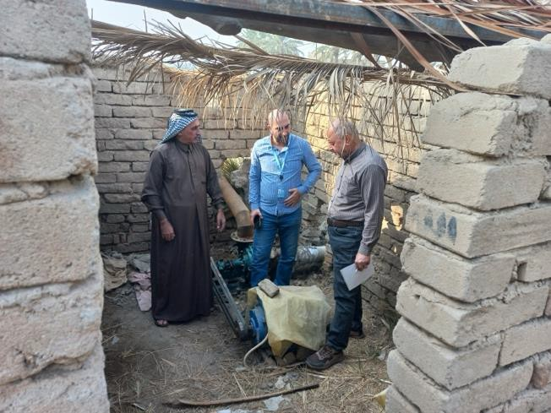
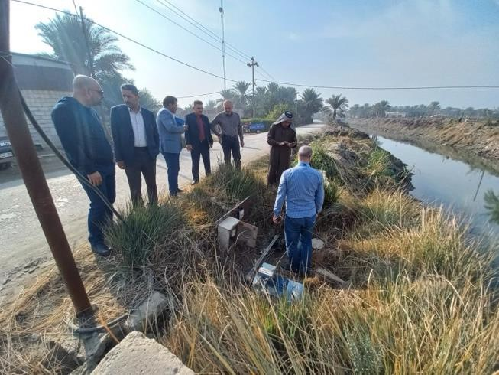
Figures 15-16: Photos by Jameel Shawkat
Figures 15-16. Consultations with farmers.

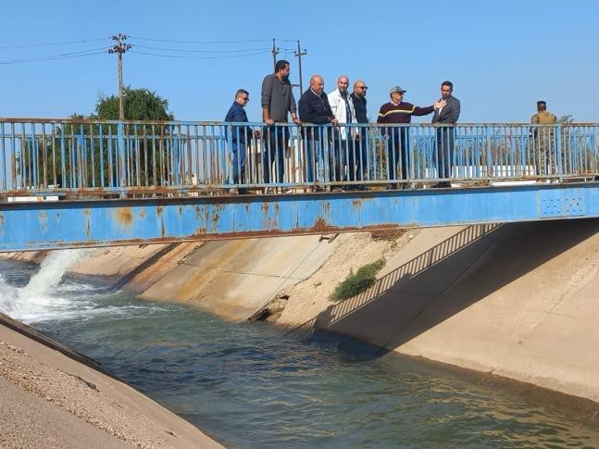
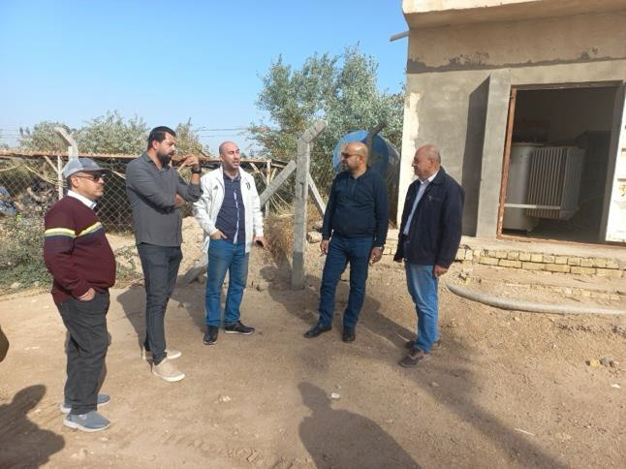
Figures 17-18: Photos by Jameel Shawkat
Figures 17-18. Visits of pump stations belonging to the Ministry of Water Resources with governmental staff at central and local level.

GRIEVANCE REDRESS MECHANISM
FAO Iraq has established a Community Feedback and Response Mechanism (CFRM) including arrangements for registering feedbacks and complaints from affected people, ensuring how the process of receiving complaints can be done, and to provide multiple access points (toll-free telephone number, sms, email and messengers) so that beneficiaries will know whom to contact with regards to their concerns. The mechanism applies to all FAO programmes and projects implemented in IRAQ.
FAO Iraq and the project team will publicize, maintain, and operate the IRAQ CFRM as an accessible Project grievance mechanism, to receive and facilitate resolution of concerns and grievances in relation to the Project, promptly and effectively, in a transparent manner that is culturally appropriate and readily accessible to all project-affected parties and project workers, at no cost and without retribution, including concerns and grievances filed anonymously, in a manner consistent with FAO’s GRM requirements.
The following contacts can be used for the project CFRM and to report possible grievances:

Review Level | Contact Details
Project Level | FAO Country Office Baghdad, Republic of Iraq  Tel. Iraq office: +964 7726175328 E-mail: FAO-IQ@fao.org
Next level | FAO Regional Office for the Near East and North Africa Cairo, Egypt.  Tel.: (202) 3331 6000 to 3331 6007  E-mail: FAO-RNE@fao.org
Office of the Inspector General (OIG) | Contact FAO's independent Office of the Inspector General:  - To report non-compliance with FAO's environmental and social management guidelines in case your grievance could not be resolved through the previously mentioned channels;  - To report non-compliance with FAO's environmental and social management guidelines in case you have a good reason for not approaching the project management (e.g., fears about your safety);  - To report possible fraud and other corrupt practices, as well as other misconduct such as sexual exploitation and abuse.  By confidential hotline (online form & by free-of-charge worldwide phone numbers with interpreters available 24 hours/day): fao.ethicspoint.com  By e-mail: Investigations-hotline@fao.org or inspector- general-office@fao.org  By mail:  Office of the Inspector General  Food and Agriculture Organization of the United Nations Viale delle Terme di Caracalla  00153 Rome, Italy

INFORMATION DISCLOSURE
Disclosure of programme and project information supports stakeholders’ ability to effectively participate in project consultations. FAO strives for project information to be relevant, understandable, accessible, and considered culturally appropriate by stakeholders. Due attention will be dedicated to specific needs in the community groups affected by project implementation. This document will be publicly disclosed on FAO's disclosure portal once formally approved. It has also been disclosed on Global Affairs Canada (GAC)’s website, and the updated version of the document responding to comments from GAC will also be disclosed on both GAC and FAO websites.

Annex: ES risk screening checklist as completed during project formulation

Full ES Risk Screening checklist for project 743047
Project Title: Adapting rural households in Southern Iraq to water scarcity induced by climate change by empowering
It has been certified on 15-Dec-2022
The table below summarizes the environmental and social risks identified in relation to the proposed action.
The proposed action is classified as: Moderate

SAFEGUARD 1 NATURAL RESOURCES MANAGEMENT
Could this project:  - result in the degradation (biological or physical) of soils or undermine sustainable land management practices; or  - include the development of a large irrigation scheme, dam construction, use of waste water or affect the quality of water; or  - reduce the adaptive capacity to climate change or increase GHG emissions significantly; or  - result in any changes to existing tenure rights¹ (formal and informal²) of individuals, communities or others to land, fishery and forest resources?  ¹Tenure rights are rights to own, use or benefit from natural resources such as land, water bodies or forests  ²Socially or traditionally recognized tenure rights that are not defined in law may still be considered to be &apos;legitimate tenure rights&apos;. | YES
SAFEGUARD 2 BIODIVERSITY, ECOSYSTEMS AND NATURAL HABITATS
Would this project be executed in or around protected areas or natural habitats, decrease the biodiversity or alter the ecosystem functionality, use alien species, or use genetic resources? | NO
SAFEGUARD 3 PLANT GENETIC RESOURCES FOR FOOD AND AGRICULTURE
Would this project:  - introduce crops and varieties previously not grown, and/or;  - provide seeds/planting material for cultivation, and/or;  - involve the importing or transfer of seeds and or planting material for cultivation or research and development;  - supply or use modern biotechnologies or their products in crop production, and/or  - establish or manage planted forests? | YES
SAFEGUARD 4 ANIMAL (LIVESTOCK AND AQUATIC) GENETIC RESOURCES FOR FOOD AND AGRICULTURE
Would this project introduce non-native or non-locally adapted species, breeds, genotypes or other genetic material to an area or production system, or modify in any way the surrounding habitat or production system used by existing genetic resources? | NO
SAFEGUARD 5 PEST AND PESTICIDES MANAGEMENT
Could this project:  - result in the direct or indirect procurement, supply or use of pesticides¹:  - on crops, livestock, aquaculture, forestry, household; or  - as seed/crop treatment in field or storage; or  - through input supply programmes including voucher schemes; or  - for small demonstration and research purposes; or  - for strategic stocks (locust) and emergencies; or | NO

- causing adverse effects to health and/or environment; or
- result in an increased use of pesticides in the project area as a result of production intensification; or
- result in the management or disposal of pesticide waste and pesticide contaminated materials; or
- result in violations of the Code of Conduct?

¹Pesticide means any substance, or mixture of substances of chemical or biological ingredients intended for repelling, destroying or controlling any pest, or regulating plant growth.
SAFEGUARD 6 INVOLUNTARY RESETTLEMENT AND DISPLACEMENT
Could this project permanently or temporarily remove people from their homes or means of production/livelihood or restrict their access to their means of livelihood? | NO
SAFEGUARD 7 DECENT WORK
Could this project affect the working conditions or job prospect beneficiaries or others who may be impacted by it, or will the project directly or indirectly employ hired labour? | YES
SAFEGUARD 8 GENDER EQUALITY
Could this project risk overlooking existing gender discrimination or inequalities in terms of men&apos;s and women&apos;s participation in decision making and/or their differential access to productive resources, services and markets? | NO
SAFEGUARD 9 INDIGENOUS PEOPLES AND CULTURAL HERITAGE
Would this project:  - have indigenous peoples* living outside the project area¹ where activities will take place; or  - have indigenous peoples living in the project area where activities will take place; or  - adversely or seriously affect on indigenous peoples&apos; rights, lands, natural resources, territories, livelihoods, knowledge, social fabric, traditions, governance systems, and culture or heritage (physical² and non-physical or intangible³) inside and/or outside the project area; or  - be located in an area where cultural resources exist?  * FAO considers the following criteria to identify indigenous peoples: priority in time with respect to occupation and use of a specific territory; the voluntary perpetuation of cultural distinctiveness (e.g. languages, laws and institutions); self- identification; an experience of subjugation, marginalization, dispossession, exclusion or discrimination (whether or not these conditions persist).  ¹The phrase "Outside the project area" should be read taking into consideration the likelihood of project activities to influence the livelihoods, land access and/or rights of Indigenous Peoples&apos; irrespective of physical distance. In example: If an indigenous community is living 100 km away from a project area where fishing activities will affect the river yield which is also accessed by this community, then the user should answer "YES" to the question.  ²Physical defined as movable or immovable objects, sites, structures, group of structures, natural features and landscapes that have archaeological, paleontological, historical, architectural, religious, aesthetic or other cultural significance located in urban or rural settings, ground, underground or underwater.  ³Non-physical or intangible defined as "the practices, representations, expressions, knowledge and skills as well as the instruments, objects, artifacts and cultural spaces associated therewith that communities, groups, and in some cases individuals, recognize as part of their spiritual and/or cultural heritage" | NO

Environme ntal and Social Safeguard question | Risk Identified | Answer | Risk category | Reference Guidance | Additional Description (if any)
1 | 1 - SAFEGUARD 1 NATURAL RESOURCES MANAGEMENT
1.1 | 1.1 - Could this project result in the degradation (biological or physical) of soils? | No | Low
1.2 | 1.2 - Could this project undermine sustainable land management practices? | No | Low
1.3 | 1.3 - Would this project develop an irrigation scheme that is more than 20 hectares or withdraws more than 1000 m3/day of water? | No | Low
1.4 | 1.4 - Would this project develop an irrigation scheme that is more than 100 hectares or withdraws more than 5000 m3/day of water? | No | Low | The ICID-checklist will be included, as well as appropriate action within the project to mitigate identified potential negative impacts.  Projects aiming at improving water efficiency will carry out thorough ongoing water accounting in order to avoid possible negative impacts such as waterlogging, salinity or reduction of water availability downstream. | Risks are related to the installation of PV-Systems on water canals. Best practices for construction works will be implemented, and all left-over construction material will be disposed of at the appropriate site and in an appropriate manner.  The execution of works by contractors will comply with established environmental, health, and safety (EHS) contractual requirements; Environmental and Social Management Plans (ESMPs) will be prepared for each sub-activity.
1.5 | 1.5 - Would this project aim at improving an irrigation scheme (without expansion)? | Yes | Moderate

1.6 | 1.6 - Could this project affect the quality of water either by the release of pollutants or by its use, thus affecting its characteristics (such as temperature, pH, DO, TSS or any other? | No | Low
1.7 | 1.7 - Would this project include the usage of wastewater? | No | Low
1.8 | 1.8 - Would this project involve the construction or financing of a dam that is more than 15 m. in height? | No | Low
1.9 | 1.9 - Would this project involve the construction or financing of a dam that is more than 5 m. in height? | No | Low
1.10 | 1.10 - Could this project result in any changes to existing tenure rights¹ (formal and informal²) of individuals, communities or others to land, fishery and forest resources?  ¹Tenure rights are rights to own, use or benefit from natural resources such as land, water bodies or forests  ²Socially or traditionally recognized tenure rights that are not defined in law may still be considered to be &apos;legitimate tenure rights&apos;. | No | Low
1.10.1 | 1.10.1 - Could this project result in a negative change to existing legitimate tenure rights? | No | Low
1.11 | 1.11 - Could this project result in a reduction of the adaptive capacity to climate change for any stakeholders in the project area? | No | Low
1.12 | 1.12 - Could this project result in a reduction of resilience against extreme weather events? | No | Low
1.13 | 1.13 - Could this project result in a net increase of GHG emissions beyond those expected from increased production? | No | Low

1.13.1 | 1.13.1 - Is the expected increase below the level specified by FAO guidance or national policy/law (whichever is more stringent)? | No | Low
1.13.2 | 1.13.2 - Is the expected increase above the level specified by FAO guidance or national policy/law (whichever is more stringent)? | No | Low

Environme ntal and Social Safeguard question | Risk Identified | Answer | Risk category | Reference Guidance | Additional Description (if any)
2 | 2 - SAFEGUARD 2 BIODIVERSITY, ECOSYSTEMS AND NATURAL HABITATS
2.1 | 2.1 - Would this project be implemented within a legally designated protected area or its buffer zone? | No | Low
2.2 | 2.2 - Could this project change a natural ecosystem to an agricultural/aquacultural/forestry production unit with a reduced diversity of flora and fauna? | No | Low
2.3 | 2.3 - Could this project increase the current impact on the surrounding environment for example by using more water, chemicals or machinery than previously? | No | Low
2.4  2.5 | 2.4 - Would this project use an alien species which has exhibited an invasive* behavior in the country or in other parts of the world or a species with unknown behavior?  *An invasive alien species is defined by the Convention on Biological Diversity as "an alien species whose introduction and/or spread threaten biological diversity" (see https://www.cbd.int/invasive/terms.shtml).  2.5 - Would this project involve access to genetic resources for their utilization and/or access to traditional knowledge associated with genetic resources that is held by indigenous, local communities and/or farmers? | No  No | Low  Low

Environme ntal and Social Safeguard question | Risk Identified | Answer | Risk category | Reference Guidance | Additional Description (if any)
3 | 3 - SAFEGUARD 3 PLANT GENETIC RESOURCES FOR FOOD AND AGRICULTURE
3.1 | 3.1 - Would this project introduce crops and varieties previously not grown? | No | Low
3.2 | 3.2 - Would this project provide seeds/planting material for cultivation? | No | Low
3.2.1 | 3.2.1 - Would this project involve the importing or transfer of seeds and/or planting materials for cultivation? | No | Low
3.2.2 | 3.2.2 - Would this project involve the importing or transfer of seeds and/or planting materials for research and development? | No | Low
3.3 | 3.3 - Would this project supply or use modern plant biotechnologies and their products? | No | Low
3.4 | 3.4 - Would this project establish or manage planted forests? | No | Low

Environme ntal and Social Safeguard question | Risk Identified | Answer | Risk category | Reference Guidance | Additional Description (if any)
4 | 4 - SAFEGUARD 4 ANIMAL (LIVESTOCK AND AQUATIC) GENETIC RESOURCES FOR FOOD AND AGRICULTURE
4.1 | 4.1 - Would this project introduce non-native or non-locally adapted species, breeds, genotypes or other genetic material to an area or production system? | No | Low
4.1.1 | 4.1.1 - Would this project foresee an increase in production by at least 30% (due to the introduction) relative to currently available locally adapted breeds and can monitor production performance? | No | Low
4.1.2 | 4.1.2 - Would this project introduce genetically altered organisms, e.g. through selective breeding, chromosome set manipulation, hybridization, genome editing or gene transfer and/or introduce or use experimental genetic technologies, e.g. genetic engineering and gene transfer, or the products of those technologies? | No | Low
4.2 | 4.2 - Would this project introduce a non-native or non-locally adapted species or breed for the first time into a country or production system? | No | Low
4.3 | 4.3 - Would this project introduce a non-native or non-locally adapted species or breed, independent whether it already exists in the country? | No | Low
4.4 | 4.4 - Would this project ensure there is no spread of the introduced genetic material into other production systems (i.e. indiscriminate crossbreeding with locally adapted species/breeds)? | No | Low

4.5 | 4.5 - Would this project collect living material from the wild, e.g. for breeding, or juveniles and eggs for ongrowing? | No | Low
4.6 | 4.6 - Could this project modify the surrounding habitat or production system used by existing genetic resources? | No | Low
4.7 | 4.7 - Would this project be located in or near an internationally recognized conservation area e.g. Ramsar or World Heritage Site, or other nationally important habitat, e.g. national park or high nature value farmland? | No | Low
4.8 | 4.8 - Could this project block or create migration routes for aquatic species? | No | Low
4.9 | 4.9 - Could this project change the water quality and quantity in the project area or areas connected to it? | No | Low
4.10 | 4.10 - Could this project cause major habitat / production system changes that promote new or unknown chances for geneflow, e.g. connecting geographically distinct ecosystems or water bodies; or would it disrupt habitats or migration routes and the genetic structure of valuable or locally adapted species/stocks/breeds? | No | Low
4.11 | 4.11 - Would this project involve the intensification of production systems that leads to land- use changes (e.g. deforestation), higher nutrient inputs leading to soil or water pollution, changes of water regimes (drainage, irrigation)? | No | Low

Environme ntal and Social Safeguard question | Risk Identified | Answer | Risk category | Reference Guidance | Additional Description (if any)
5 | 5 - SAFEGUARD 5 PEST AND PESTICIDES MANAGEMENT
5.1 | 5.1 - Would this project procure, supply and/or result in the use of pesticides on crops, livestock, aquaculture or forestry? | No | Low
5.2 | 5.2 - Would this project provide seeds or other materials treated with pesticides (in the field and/or in storage)? | No | Low
5.3 | 5.3 - Would this project provide inputs to farmers directly or through voucher schemes? | No | Low
5.4 | 5.4 - Could this project lead to increased use of pesticides through intensification or expansion of production? | No | Low
5.5 | 5.5 - Would this project manage or dispose of waste pesticides, obsolete pesticides or pesticide contaminated waste materials? | No | Low

Environme ntal and Social Safeguard question | Risk Identified | Answer | Risk category | Reference Guidance | Additional Description (if any)
6 | 6 - SAFEGUARD 6 INVOLUNTARY RESETTLEMENT AND DISPLACEMENT
6.1 | 6.1 - Would this removal¹ be voluntary?  ¹temporary or permanent removal of people from their homes or means of production/livelihood or restrict their access to their means of livelihoods | No | Low

Environme ntal and Social Safeguard question | Risk Identified | Answer | Risk category | Reference Guidance | Additional Description (if any)
7 | 7 - SAFEGUARD 7 DECENT WORK
7.1 | 7.1 - Could this project displace jobs? (e.g. because of sectoral restructuring or occupational shifts) | No | Low
7.2 | 7.2 - Would this project operate in sectors or value chains that are dominated by subsistence producers and other vulnerable informal agricultural workers, and more generally characterized by high levels "working poverty"? | Yes | Moderate | Take action to anticipate the likely risk of perpetuating poverty and inequality in socially unsustainable agriculture and food systems. Decent work and productive employment should appear among the priorities of the project or, alternatively, the project should establish synergies with specific employment and social protection programmes e.g. favouring access to some social protection scheme or form of social insurance. Specific measures and mechanisms should be introduced to empower in particular the most vulnerable  /disadvantaged categories of rural workers such as small-scale producers, contributing family workers, subsistence farmers, agricultural informal wage workers, with a special attention to women and youth who are predominantly found in these employment statuses. An age- and gender- sensitive social value chain analysis or livelihoods/employment assessment is needed for large-scale projects.
7.3 | 7.3 - Would this project operate in situations where youth work mostly as unpaid contributing family workers, lack access to decent jobs and are increasingly abandoning agriculture and rural areas? | No | Low
7.4 | 7.4 - Would this project operate in situations where major gender inequality in the labour | Yes | Moderate | Take action to anticipate likely risk of socially unsustainable agriculture and food | Potential risks could be related to equitable benefits from project

 | market prevails? (e.g. where women tend to work predominantly as unpaid contributing family members or subsistence farmers, have lower skills and qualifications, lower productivity and wages, less representation and voice in producers&apos; and workers&apos; organizations, more precarious contracts and higher informality rates, etc.) |  |  | systems by integrating specific measures to reduce gender inequalities and promote  rural women’s social and economic empowerment. A specific social value chain analysis or livelihoods/employment assessment is needed for large-scale projects.Facilitation should be provided for women of all ages to access productive resources (including land), credit, markets and marketing channels, education and TVET, technology, collective action or mentorship. Provisions for maternity protection, including child care facilities, should be foreseen to favour women participation and anticipate potential negative effects on child labour, increased workloads for women, and health related risks for pregnant and breastfeeding women. | activities. To address this, project activities specifically target women (ref. Climate Wise Women activities). Occupational health and safety risks will be dealt with by providing training and protective measures and gear as well as provisions for protecting workers. Where the project hires workers, employees’ rights as per UN/FAO standards will be respected. The employment of project workers will be based on the principle of equal opportunity and fair treatment, and there will be no discrimination with respect to any aspects of the employment relationship.
7.5 | 7.5 - Would this project operate in areas or value chains with presence of labour migrants or that could potentially attract labour migrants? | No | Low
7.6 | 7.6 - Would this project directly employ workers? | No | Low
7.7 | 7.7 - Would this project involve sub-contracting? | Yes | Moderate | Take action to anticipate likely risk of perpetuating inequality and labour rights violations by introducing complementary measures. FAO projects involving sub- contracting should promote, to the extent possible, subcontracting to local entrepreneurs - particularly to rural women and youth - to maximize employment creation under decent working conditions. Also, FAO should monitor and eventually support contractors to fulfil the standards of performance and quality, taking into account national and international social and labour standards.
7.8 | 7.8 - Would this project operate in a sector, area or value chain where producers and other agricultural workers are typically exposed to significant | No | Low

occupational and safety risks*

*Major OSH risks in agriculture include: dangerous machinery and tools; hazardous chemicals; toxic or allergenic agents; carcinogenic substances or agents; parasitic diseases; transmissible animal diseases; confined spaces; ergonomic hazards; extreme temperatures; and contact with dangerous and poisonous animals, reptiles and insects.
7.9 | 7.9 - Would this project provide or promote technologies or practices that pose occupational safety and health (OSH) risks for farmers, other rural workers or rural populations in general? | No | Low
7.10 | 7.10 - Would this project foresee that children below the nationally-defined minimum employment age (usually 14 or 15 years old) will be involved in project-supported activities? | No | Low
7.11 | 7.11 - Would this project foresee that children above the nationally-defined minimum employment age (usually 14 or 15 years old), but under the age of 18 will be involved in project- supported activities? | No | Low
7.12 | 7.12 - Would this project operate in a value chain where there have been reports of child labour? | No | Low
7.13 | 7.13 - Would this project operate in a value chain or sector where there have been reports of forced labour*?  *Forced labour is employed, consists of any work or service not voluntarily performed that is exacted from an individual under threat of force or penalty. It includes men, women and children in situations of debt bondage, suffering slavery-like conditions or who have been trafficked. "In many countries, agricultural work is largely informal, and legal protection of workers is weak. In South Asia, there is still evidence of bonded labour in agriculture, | No | Low

resulting in labour arrangements where landless workers are trapped into exploitative and coercive working conditions in exchange for a loan. The low wages associated with high interest rates make it quite difficult for whole families to escape this vicious circle. In Africa, the traditional forms of &apos;vestiges of slavery&apos; are still prevalent in some countries, leading to situations where whole families (adults and children, men and women) are forced to work the fields of landowners in exchange for food and housing. In Latin America, the case of workers recruited in poor areas and sent to work on plantations or in logging camps has been widely documented by national inspection services and other actors." (ILO, Profits and poverty: the economics of forced labour / International Labour Office. - Geneva: ILO, 2014

Environme ntal and Social Safeguard question | Risk Identified | Answer | Risk category | Reference Guidance | Additional Description (if any)
8 | 8 - SAFEGUARD 8 GENDER EQUALITY
8.1 | 8.1 - Could this project risk reinforcing existing gender-based discrimination, by not taking into account the specific needs and priorities of women and girls? | No | Low
8.2 | 8.2 - Could this project not target the different needs and priorities of women and men in terms of access to services, assets, resources, markets, and decent employment and decision-making? | No | Low

Environme ntal and Social Safeguard question | Risk Identified | Answer | Risk category | Reference Guidance | Additional Description (if any)
9 | 9 - SAFEGUARD 9 INDIGENOUS PEOPLES AND CULTURAL HERITAGE
9.1 | 9.1 - Are there indigenous peoples* living outside the project area** where activities will take place?  *FAO considers the following criteria to identify indigenous peoples: priority in time with respect to occupation and use of a specific territory; the voluntary perpetuation of cultural distinctiveness (e.g. languages, laws and institutions); self- identification; an experience of subjugation, marginalization, dispossession, exclusion or discrimination (whether or not these conditions persist).  **The phrase "Outside the project area" should be read taking into consideration the likelihood of project activities to influence the livelihoods, land access and/or rights of Indigenous Peoples&apos; irrespective of physical distance. In example: If an indigenous community is living 100 km away from a project area where fishing activities will affect the river yield which is also accessed by this community, then the user should answer "YES" to the question. | No | Low
9.1.1 | 9.1.1 - Do the project activities influence the Indigenous Peoples living outside the project area? | No | Low
9.2 | 9.2 - Are there indigenous peoples living in the project area where activities will take place? | No | Low
9.3 | 9.3 - Would this project adversely or seriously affect on indigenous peoples&apos; rights, lands, natural resources, territories, livelihoods, knowledge, social fabric, traditions, governance | No | Low

systems, and culture or heritage (physical* and non-physical or intangible**) inside and/or outside the project area?

*Physical defined as movable or immovable objects, sites, structures, group of structures, natural features and landscapes that have archaeological, paleontological, historical, architectural, religious, aesthetic or other cultural significance located in urban or rural settings, ground, underground or underwater.

**Non-physical or intangible defined as "the practices, representations, expressions, knowledge and skills as well as the instruments, objects, artifacts and cultural spaces associated therewith that communities, groups, and in some cases individuals, recognize as part of their spiritual and/or cultural heritage"
9.4 | 9.4 - Would this project be located in an area where cultural resources exist? | No | Low

Additional Information
 | Answer | Remarks
ADDITIONAL INFORMATION
Is there any other potential environmental and/or social risk of this project that has not been captured in the screening checklist? | No
Is the proposed project considered potentially controversial? | No

Barley is also an important crop for livestock feeding in Iraq
https://www.sciencedirect.com/topics/engineering/evaporation-rate
The project is designed to respond to these challenges and to optimize water use in agriculture by improving agricultural productivity and emphasizing irrigation system efficiency, as well as working with public and private extension services to increase the adoption of advanced production technologies and practices. Investing in policy and legal reforms, and strengthening water resources planning, management, and governance can result in supporting a paradigm shift in the infrastructure investments for both the water and energy sectors. Farmers in the project area rely on climate-sensitive livelihoods with limited scope for diversification. There is high dependence on crop varieties that are not stress-tolerant and lack of information and access to efficient irrigation technologies, both of which can severely undermine food security. Rice and corn farmers are forced to assess alternate options as the state has started to ban the production of rice and corn in years when there is drought or insufficient water in the irrigation system [HYPERLINK "https://nypost.com/2018/07/05/iraq-bans-farming-because-theyre-running-out-of-water/"NYP, 2018]. There is also limited farmer awareness about climate resilient technologies and practices and limited access to actionable climate information. Flood irrigation is still practiced leading to considerable inefficiencies in water use (30 to 35% irrigation efficiency throughout the country). The agriculture extension services for technology transfer, particularly for small producers, are weak and in need of new climate adaptive skills. Farmers do not have the knowledge and skills to address the adaptation deficit by themselves. As a general rule, CSI approaches recommend that CSI projects focus initially on improving the performance, productivity and profitability of existing irrigated crop production systems. This entry point is recommended because irrigation systems where farmers have adopted good irrigation practices tend to be more resilient to climate change than systems that, for one reason or another, are underperforming. There is also a significant risk that investment in CSI adaptation and/or mitigation will be ineffective if farmers are lacking in, for example, crop husbandry and water management know-how, or irrigation systems are not performing well because sources of water are, for example, being overexploited or systems are not well maintained. FAO analysis of local meteorological data confirms an increase in exposure in long term hydrological drought for 24 months on a national level

